
Syrian Arab Republic
Syrian Private University
Faculty of Informatics Engineering
Department of Information Engineering –
Software Engineering and Information Systems

Software System for Managing an Agricultural Facility (Poultry Farming)

Prepared by
Alaa George Karma

Supervision
Dr. Fady Ibrahim

Academic Year
2025/2026
Supervisor's Acknowledgment

I certify that the preparation of this project tagged
is a software system for the management of an agricultural facility (poultry farming).
Prepared by the student:
Alaa George Karma
I have been under my supervision in the Department of Software and Information Systems Engineering – College of Computer, Informatics and Communication Engineering, which is part of the requirements for obtaining a bachelor's degree in Software and Information Systems Engineering.
Scientific Rank.................... Name............................ Signature

History

Abstract

This project aims to develop an intelligent software system for the management of an agricultural facility specialized in poultry farming, in order to provide an integrated and safe environment to follow up daily operations, and to improve production efficiency and data quality.
The system focuses on meeting the needs of farmers and administrators by facilitating inventory control, feeding and grafting scheduling, growth and production tracking, as well as sales and reporting management.
The objectives of the project include:
- Creating a reliable and secure system that protects data from any cyber threat.
- Easy user interface design that supports the daily work of the farm.
- Integrate the system with publishing tools and reports for accurate and transparent follow-up.
The project goes through the following phases:
- Analysis: Requirements collection and workflow analysis within the poultry facility.
- Design: Develop a system structure plan using UML models and databases.
- Implementation: System development using modern technologies such as React and Node.js.
- Testing: Checking the efficiency and security of the system, and ensuring that it is compatible with the needs of users.

This system contributes to transforming the management of poultry farms from the traditional method to the digital method, which contributes to raising productivity, reducing waste and improving the quality of management decisions.

Charts Index
3.4 Activity Diagram: 21
3.4.1 Activity Diagram of Manage user data (add/modify/delete): 22
3.4.2 Activity Diagram of View system settings: 22
3.4.3 Activity Diagram of Monitor activity logs to keep track of system usage: 23
3.4.4 Activity Diagram of Change user account status (Active/Freeze): 23
3.4. 5Activity Diagram of View general system statistics: 24
3.4.6 Activity Diagram of Create production and profit reports based on available data: 24
3.4.7 Activity Diagram of Plan and schedule Resources(food/fuel): 25
3.4.8 Activity Diagram of Request feed from the food supplier: 26
3.4.9 Activity Diagram of Request vaccines and medicines from the veterinarian: 26
3.4.10 Activity Diagram of Request equipment from the equipment supplier: 27
3.4.11 Activity Diagram of Send new purchase orders to suppliers: 27
3.4.12 Activity Diagram of Assign a new worker: 28
3.4.13 Activity Diagram of Track and analyze performance data to identify improvement opportunities and make strategic decisions: 29
3.4.14 Activity Diagram of Send a recommendation to improve activity logs: 30
3.4.15 Activity Diagram of Send a recommendation to improve production (feed quantity – number of eggs produced): 30
3.4.16 Activity Diagram of Send a recommendation to improve facility resource utilization: 31
3.4.17 Activity Diagram of Set minimum inventory to alert the system when feed or fuel is low: 31
3.4.18 Activity Diagram of Review the annual archive of previous facility data: 32
3.4.19 Activity Diagram of Recording veterinary examinations for individual and group cases: 33
3.4.20 Activity Diagram of Follow-up of prevention and treatment plans: 33
3.4.21 Activity Diagram of Providing recommendations to improve the healthy environment within the facility: 34
3.4.22 Activity Diagram of Providing specialized feeding plans to ensure the health and proper growth of poultry: 34
3.4.23 Activity Diagram of Displaying and printing the reports log: 35
3.4.24 Activity Diagram of Recording the daily mortality rate of birds 35
3.4.25 Activity Diagram of Printing and exporting proposed “prescriptions” to send to the manager or suppliers: 36
3.4.26 Activity Diagram of Recording daily poultry feeding data: 36
3.4.27 Activity Diagram of Report abnormalities using simple forms: 37
3.4.28 Activity Diagram of Updating the facility's cleanliness status: 37
3.4.29 Activity Diagram of Assisting with sorting and packing operations when preparing poultry for sale: 38
3.4.30 Activity Diagram of Viewing and printing sorting and packing operations: 38
3.4.31 Activity Diagram of Viewing and printing reports from the suppliers and the veterinarian: 39
3.4.32 Activity Diagram of Edit reports received from the suppliers and the veterinarian: 39
3.4.33 Activity Diagram of Record daily attendance and departure times: 40
3.4.34 Activity Diagram of Viewing the daily tasks schedule assigned by management: 41
3.4.35 Activity Diagram of Adding details of the food items supplied (quantity/quality): 41
3.4.36 Activity Diagram of Submitting direct quotations via the system: 42
3.4.37 Activity Diagram of Edit and delete quotations: 42
3.4.38 Activity Diagram of Update the status of previous orders (Delivered/Not Delivered): 43
3.4.39 Activity Diagram of Provide reports on food consumption: 43
3.4.40 Activity Diagram of Editing, deleting and printing food consumption reports: 44
3.4.41 Activity Diagram of Updating the supplier’s profile and contact information: 44
3.4.42 Activity Diagram of Viewing the history of previous quotations for reference: 45
3.4.43 Activity Diagram of Recording the amount of fuel supplied in each operation: 45
3.4.44 Activity Diagram of Report any delivery problem: 46
3.4.45 Activity Diagram of Submitting periodic reports on fuel consumption: 46
3.4.46 Activity Diagram of Providing recommendations to improve fuel efficiency and reduce costs: 47
3.4.47 Activity Diagram of Editing, deleting and printing fuel status reports: 47
3.4.48 Activity Diagram of Updating availability dates and delivery times available: 48
3.4.49 Activity Diagram of Displaying financial invoices received and related to delivered shipments: 48
3.6 Use Case Diagram: 51
3.7.1 Use Case Diagram for System Admin: 52
3.7.2 Use Case Diagram for Facility Manager: 56
3.7.3 Use Case Diagram for Veterinarian: 66
3.7.4 Use Case Diagram for Employee: 71
3.7.5 Use Case Diagram for Feed Supplier: 76
3.7.6 Use Case Diagram for Fuel Supplier: 81
Sequence Diagram:3.8 85
3.8.1 Manage user data (add/modify/delete): 86
3.8.2 View system settings: 86
3.8.3 Monitor activity logs to keep track of system usage: 86
3.8.4 Change user account status (Active/Freeze): 87
3.8.5 View general system statistics: 87
.6 Create production and profit reports based on available data: 3.8 88
3.8.7 Plan and schedule Resources(food/fuel): 88
3.8.8 Request feed from the food supplier: 89
3.8.9 Send new purchase orders to suppliers: 89
3.8.10 Request vaccines and medicines from the veterinarian: 90
3.8.11 Track and analyze performance data to identify improvement opportunities and make strategic decisions: 90
3.8.12 Request equipment from the equipment supplier: 91
3.8.13 Send a recommendation to improve activity logs: 91
3.8.14 Send a recommendation to improve production (feed quantity – number of eggs produced): 92
3.8.15 Send a recommendation to improve facility resource utilization: 92
3.8.16 Assign a new worker: 93
3.8.17 Set minimum inventory to alert the system when feed or fuel is low: 93
3.8.18 Review the annual archive of previous facility data: 94
3.8.19 Recording veterinary examinations for individual and group cases 94
3.8.20 Providing specialized feeding plans to ensure the health and proper growth of poultry: 95
3.8.21 Displaying and printing the reports log: 95
3.8.22 Follow-up of prevention and treatment plans: 96
3.8.23 Providing recommendations to improve the health environment within the facility: 96
3.8.24 Recording the daily mortality 97
3.8.25 Printing and exporting proposed “prescriptions” to send to the manager or suppliers: 97
3.8.26 Recording daily poultry feeding data: 98
3.8.27 Viewing and printing sorting and packing operations: 98
3.8.28 Viewing and printing reports from the suppliers and the veterinarian: 99
3.8.29 Edit reports received from the suppliers and the veterinarian: 99
3.8.30 Report abnormalities using simple forms: 100
3.8.31 Updating the facility's cleanliness status: 100
3.8.32 Assisting with sorting and packing operations when preparing poultry for sale: 100
3.8.33 Record daily attendance and departure times: 101
3.8.34 Viewing the daily tasks schedule assigned by management: 101
3.8.35 Submitting direct quotations via the system: 102
3.8.36 Edit and delete quotations: 102
3.8.37 Provide reports on food consumption to determine future quantities required: 103
3.8.38 Editing, deleting and printing food consumption reports: 103
3.8.39 Update the status of previous orders (Delivered/Not Delivered): 104
3.8.40 Adding details of the food items supplied: 104
3.8.41 Updating the supplier’s profile and contact information: 105
3.8.42 Viewing the history of previous quotations for reference: 105
3.8.43 Recording the amount of fuel supplied in each operation: 106
3.8.44 Report any delivery problem: 106
3.8.45 Submitting periodic reports on fuel consumption: 106
3.8.46 Providing recommendations to improve fuel efficiency and reduce costs: 107
3.8.47 107
3.8.48 Updating availability dates and delivery times available: 108
3.8.49 Displaying financial invoices received and related to delivered shipments: 108
4.1 Class Diagram: 114
4.3 Components Diagram: 116
4.4 ERD Diagram: 116
5.4 Interfaces chart: 129

Table of Contents
Chapter One: Introduction 9
1.1 Introduction to the project topic: 10
1.2 Justifications: 10
1.3 Project Objective: 10
Chapter Two: Research Topic 11
and the reference study 11
2.1 Introduction: 12
2.2 Future Prospects: 12
2.3 Reference Study: 12
Summary of the interviews: 14
Chapter Three: The Analytical Stage 15
of the proposed system 15
3.1 Feasibility: 16
3.1.1 Economic feasibility of the project: 16
3.1.2 Social feasibility of the project: 16
3.1.3 Legal feasibility of the project: 16
3.2 Methodology Used: 16
3.2.2 Stages of the Cumulative Gradual Development Methodology: 16
3.2.3 Project Timeline (Gantt Chart): 17
3.3.1 Functional Requirements: 18
3.3.2 Non-Functional Requirements: 20
3.5 Table of Actors and Use Cases: 49
3.7 Textual Description of Use Cases: 52
Chapter Four: Design Study 113
4.2 System Architecture: 114
Chapter Five: implementation 117
5.1 Tools Used: 118
5.2 Test Cases: 122
5.3 System interfaces: 126
5.4 Sitemap: 129
Chapter six: Conclusions and Future Prospects 130
6.1 Conclusion: 131
6.2 Future work: 131
6.3 Final Goal: 131
6.4 References: 132

Vocabularies table

Term | Abbreviation | المصطلح بالعربية | Brief Explanation
Poultry Farming | - | تربية الدواجن | Agricultural sector for raising birds for meat and eggs.
Software System | - | نظام برمجي | Software components for digital facility management.
User Interface | UI | واجهة المستخدم | The medium through which users interact with the system.
Unified Modeling Language | UML | لغة النمذجة الموحدة | Graphical models for planning system and database structure.
Database | DB | قاعدة بيانات | Organized storage for facility data like inventory and production.
Incremental Development | - | التطوير التراكمي | Methodology of building and integrating system units sequentially.
Functional Requirements | - | المتطلبات الوظيفية | Operations and tasks the system must perform for users.
Non-functional Requirements | - | المتطلبات غير الوظيفية | System quality attributes like security, performance, and flexibility.
Economic Feasibility | - | الجدوى الاقتصادية | Studying project profitability and website impact on performance.
Social Feasibility | - | الجدوى الاجتماعية | Studying website impact on community communication.
Legal Feasibility | - | الجدوى القانونية | Ensuring website compliance with applicable laws and regulations.
System Admin | - | مدير النظام | Person responsible for managing users and general settings.
Facility Manager | - | مدير المنشأة | Responsible for production reports, profits, and resource planning.
Veterinarian | Vet | الطبيب البيطري | Responsible for healthcare and preventive plans for poultry.
Employee | - | الموظف | Responsible for recording daily feeding and hygiene data.
Food Supplier | - | تاجر المواد الغذائية | Supplier responsible for feed details and price quotes.
Fuel Supplier | - | تاجر الوقود | Supplier responsible for fuel delivery and consumption reports.
Use Case Diagram | - | مخطط حالات الاستخدام | Diagram showing interaction between actors and system functions.
Activity Diagram | - | مخطط النشاط | Describes the workflow within various system processes.
Sequence Diagram | - | مخطط التتابع | Illustrates the timed interaction between components for a process.
Class Diagram | - | مخطط الأصناف | Represents the software structure and object relationships.
Entity Relationship Diagram | ERD | مخطط علاقات الكيانات | Model showing database tables and their relationships.
Model View Controller | MVC | هيكلية النموذج-العرض-المتحكم | Architectural pattern dividing the app for easier development.
Application Programming Interface | API | واجهة برمجة التطبيقات | Allows data exchange and communication between systems.
Hypertext Markup Language 5 | HTML5 | لغة توصيف النص | Standard for developing modern interactive web pages.
Cascading Style Sheets 3 | CSS3 | لغة تنسيق الصفحات | Used for designing and formatting the appearance of web pages.
JavaScript | JS | لغة جافا سكريبت | Programming language for building interactive web applications.
React | - | رياكت | Library for building scalable and interactive user interfaces.
Node.js | - | نود جي إس | Runtime environment for executing JavaScript on the server side.
Express.js | - | إكسبريس جي إس | Lightweight framework for building web apps and APIs.
MongoDB | - | مونغو دي بي | Non-relational (NoSQL) database storing data as documents.

Chapter One: Introduction

1.1 Introduction to the project topic:
The project addresses a software system for the management of a poultry farming facility and its role in improving the efficiency of operations and increasing productivity. The project aims to develop an integrated platform that facilitates the management of various aspects of the facility, such as monitoring bird health, nutrition management, scheduling activities, and production tracking. The platform supports interaction between employees in the facility through an easy-to-use interface to improve decision-making and ensure the sustainability of production.

1.2 Justifications:
Traditional poultry farming facilities suffer from significant challenges, such as the difficulty of efficiently managing resources, the inability to accurately monitor birds, as well as limitations related to immediate interaction between workers. Many of the current software systems also suffer from poor customization of solutions to meet the specific needs of each facility, lack of support for data analysis and decision-making, and lack of integration with modern technological tools such as sensors.

1.3 Project Objective:
This project aims to study the impact of the software system on improving the efficiency of poultry farming facility management and developing operational process monitoring methods. It also seeks to develop a software platform characterized by accuracy, customization, and ease of use, with a focus on meeting the needs of different facilities and supporting data-driven decision-making to improve productivity and ensure the sustainability of operations.

Chapter Two: Research Topic

and the reference study

2.1 Introduction:
In light of the digital revolution and the continuous development of information and communication technology, it has become necessary for the productive sectors, especially the agricultural sector, to adopt smart and advanced systems that contribute to improving efficiency and productivity. Poultry farming is one of the most important branches of agricultural production that requires careful monitoring and effective management of various elements such as health care, nutrition, temperature, ventilation, and daily production.
Based on the increasing successes of e-learning technologies and smart software in improving the performance of educational and training institutions, it is wise to employ the same principles in the agricultural sectors through flexible and up-to-date digital systems that enable facility owners to monitor and operate operations efficiently through smart electronic platforms. The proposed software system for the management of a poultry farming facility is a paradigm shift in traditional management methods, as it provides tools for recording and analyzing data, issuing automatic alerts, and providing periodic reports that support the adoption of decision, which contributes to reducing costs, increasing returns, and improving the quality of production.

2.2 Future Prospects:
- Growth in demand for products: The demand for poultry products is expected to witness a continuous increase, which will enhance the growth opportunities for the facility.
- Digital market expansion: E-commerce will continue to grow, pushing agricultural enterprises to strengthen their digital presence and increase their investments in digital marketing
- Increased environmental awareness: As awareness of sustainability issues increases, enterprises will move towards more sustainable poultry farming practices, which can impact business operations

2.3 Reference Study:
In order to ensure that our project will meet the needs of users, we reached out to a number of people who own poultry farms and asked a number of questions and will now present the results of the interviews:

2.3.1 First Interview:
Name of the person or establishment: | Youssef
What are the basic features you need in the website? | The site must include a sales management system
How would you prefer the information to be displayed? | Better Having an Easy User Interface
Do you need a notification system? | yes
What challenges are you currently facing? | Difficulty tracking the health status of poultry

2.3.2 Second Interview:
Name of the person or establishment: | Firas
What are the basic features you need in the website? | Poultry Health Data Management System
How would you prefer the information to be displayed? | Information should be presented in an orderly and uncomplicated manner
Do you need a notification system? | Yes, of course, especially in tracking deaths.

2.3.3 Third Interview:
Name of the person or establishment: | Mohammed
What are the basic features you need in the website? | Temperature Monitoring System
How would you prefer the information to be displayed? | The information must be presented in an orderly manner
Do you need a notification system? | Yes, of course, especially in temperature tracking.
What challenges are you currently facing? | Difficulty managing data in general

2.3.4 Fourth Interview:
Name of the person or establishment: | Ahmed
What are the basic features you need in the website? | Employee Work Management System
How would you prefer the information to be displayed? | I prefer having a special section for employees
Do you need a notification system? | Yes, of course especially in tracking workers' performance
What challenges are you currently facing? | Difficulty in organizing work among employees

Summary of the interviews:
After the study we presented above, we noticed a disparity in the problems suffered by the owners and managers of the establishments, and this creates a challenge for us to prove the merit of our project in satisfying all users.

Chapter Three: The Analytical Stage

of the proposed system

3.1 Feasibility:

3.1.1 Economic feasibility of the project:
Poultry farming is a lucrative agricultural activity, and with the increasing reliance on technology in agriculture, creating an agricultural enterprise website becomes essential. This economic study aims to analyze the economic feasibility of a website and its impact on the performance of the establishment.

3.1.2 Social feasibility of the project:
The website of an agricultural poultry farming facility is a vital tool to enhance communication between the facility and the local community. This social study aims to analyze the impact of the site on the community from various aspects.

3.1.3 Legal feasibility of the project:
Websites are an essential part of modern business, and running a website for a poultry farm requires adherence to a number of laws and regulations. This study aims to highlight the key legal aspects to consider.

3.2 Methodology Used:
3.2.1 Incremental development is an information systems development method that divides the entire system into functional units or small increments that are built and integrated sequentially at specific stages of time. In each development cycle, a usable component or set of components is produced, so that the final system evolves gradually and acquires more functionality with each iteration.

3.2.2 Stages of the Cumulative Gradual Development Methodology:
- Increment Planning:
The overall system is broken down into small increments or parts that are developed at specific intervals. In this stage, priorities are set for the core functions that need to be delivered first as well as the implementation sequence is defined so that each increment has a complete and independent value.
- System Architectural Design: A
general architectural model is developed to ensure that all increases are compatible later. The design includes drawing the structural plans of the system and identifying the main units that allow future increases to be seamlessly integrated.
- Design and plan the details of the new increase:
For each increase, a detailed design is prepared that shows how the added functionality will be achieved in that cycle. During the design, it is taken into account that it is adjustable as needed based on future observations or changes in requirements.
- Implementation (Unit Development):
The development of the new unit or addition based on the detailed design using appropriate programming languages and techniques. The application of quality and testing standards is taken into account during the writing of the code while incorporating the principles of clean programming.
- Individual Testing and Integration Testing:
The unit developed is individually tested to ensure that there are no functional or technical errors, and then integration testing is performed to ensure that the new unit is compatible with the existing kernel and the rest of the system.
- Integration of the increase into the main system and conducting comprehensive testing:
After passing the unit and integration tests, the increase is integrated into the general system, and user acceptance testing is conducted to ensure that all new functions are working according to the required specifications.
- Evaluation and Feedback Collection:
The updated version is presented to stakeholders for feedback gathering and feedback. This feedback is analyzed to determine if additional adjustments or improvements are needed in future cycles.
- Iteration and development of the following increments:
The cycle continues by repeating the steps from design to implementation and testing for each new increment. This iteration ensures that the system progressively evolves with more functionality according to the chosen priorities.
- Final Deployment, Follow-up and Maintenance:
After all planned increases are completed and confidence in the quality of the system is achieved, the entire system is deployed. Regular maintenance and update practices are also followed based on system usage and operational feedback to ensure continuity of performance.

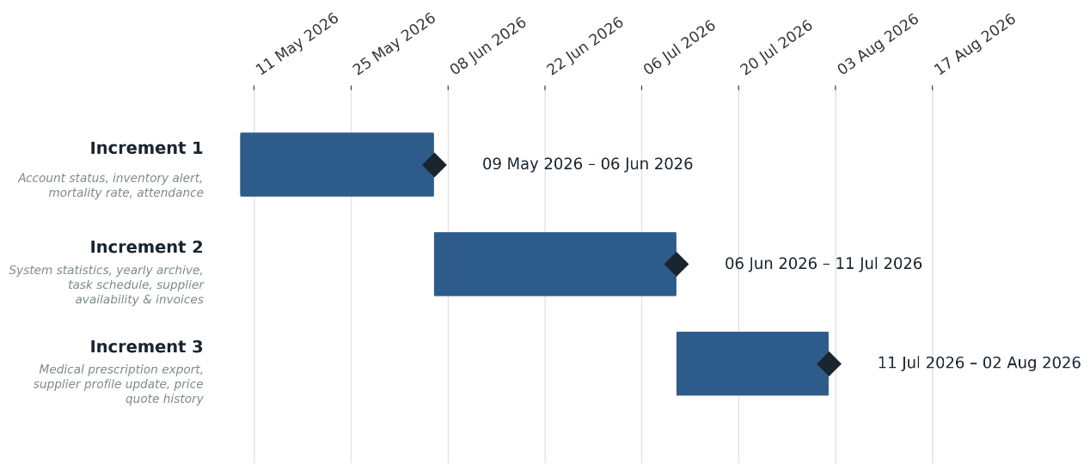
3.2.3 Project Timeline (Gantt Chart):

  - System Requirements:

3.3.1 Functional Requirements:
- Functional Requirements for System Admin:
- Manage user data (add/modify/delete).
- View system settings.
- Monitor activity logs to keep track of system usage.
- Change user account status (Active/Freeze).
- View general system statistics.

- Functional Requirements for the Facility Manager:
- Create production and profit reports based on available data.
- Plan and schedule Resources(food/fuel).
- Send new purchase orders to suppliers.
- Track and analyze performance data to identify improvement opportunities and make strategic decisions.
- Request feed from the food supplier.
- Request vaccines and medicines from the veterinarian.
- Request equipment from the equipment supplier.
- Assign a new worker.
- Send a recommendation to improve activity logs.
- Send a recommendation to improve production (feed quantity – number of eggs produced).
- Send a recommendation to improve facility resource utilization.
- Set minimum inventory to alert the system when feed or fuel is low.
- Review the annual archive of previous facility data.

- Functional Requirements for the Veterinarian:
- Recording veterinary examinations for individual and group cases.
- Follow-up of prevention and treatment plans.
- Providing recommendations to improve the healthy environment within the facility.
- Providing specialized feeding plans to ensure the health and proper growth of poultry.
- Displaying and printing the reports log.
- Recording the daily mortality rate of birds.
- Printing and exporting proposed “prescriptions” to send to the manager or suppliers.

- Functional Requirements for the Employee:
- Recording daily poultry feeding data.
- Report abnormalities using simple forms.
- Updating the facility's cleanliness status.
- Assisting with sorting and packing operations when preparing poultry for sale.
- Viewing and printing sorting and packing operations.
- Viewing and printing reports from the suppliers and the veterinarian.
- Edit reports received from the suppliers and the veterinarian.
- Record daily attendance and departure times.
- Viewing the daily tasks schedule assigned by management.

- Functional Requirements for Food Supplier:
- Adding details of the food items supplied (quantity/quality).
- Submitting direct quotations via the system.
- Update the status of previous orders (Delivered/Not Delivered).
- Edit and delete quotations.
- Provide reports on food consumption to determine future quantities required.
- Editing, deleting and printing food consumption reports.
- Updating the supplier’s profile and contact information.
- Viewing the history of previous quotations for reference.

- Functional Requirements for Fuel Supplier:
- Recording the amount of fuel supplied in each operation.
- Report any delivery problem.
- Submitting periodic reports on fuel consumption.
- Providing recommendations to improve fuel efficiency and reduce costs.
- Editing, deleting and printing fuel status reports.
- Updating availability dates and delivery times available.
- Displaying financial invoices received and related to delivered shipments.

3.3.2 Non-Functional Requirements:

- React provides a component design that can be easily expanded.
- Supports Node.js efficient resource management, even as data volume increases.
  - Security:
- Data encryption techniques can be used during client-server (TLS/SSL) communication.
- Node.js allows permissions control for system users such as (admin and administrator).
  - Performance:
- React ensures fast and interoperable interfaces.
- Node.js processes orders quickly without causing delays or system suspensions.
  - Flexibility:
- React supports quick interface updates such as adding new functions.
- Node.js allows the database to be modified and software changes easily.
  - Portability and compatibility:
- The system can work on different types of devices thanks to the modern design of the user interface.
- Node.js ensures system compatibility with multiple databases such as MongoDB or MySQL.
  - Reliability:
- React and Node.js contribute to building a stable and responsive system.

3.4 Activity Diagram:
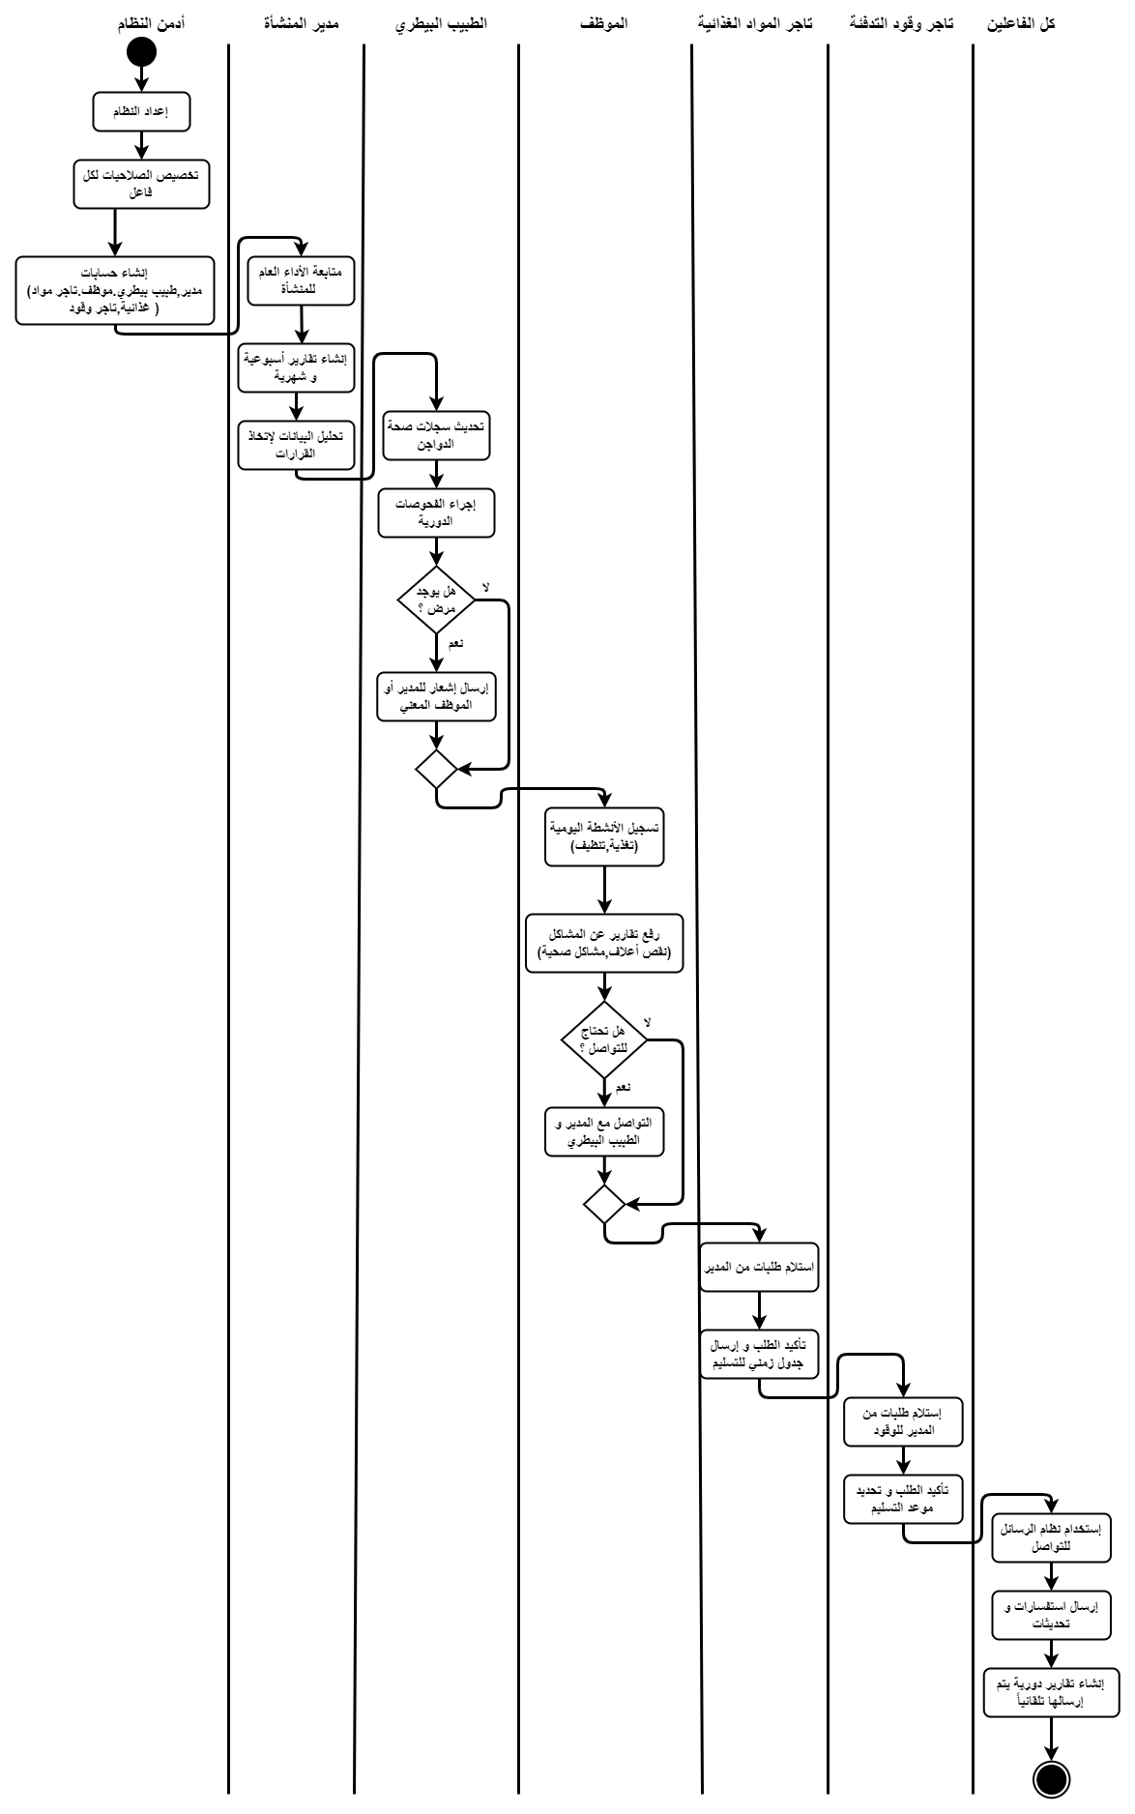

3.4.1 Activity Diagram of Manage user data (add/modify/delete):
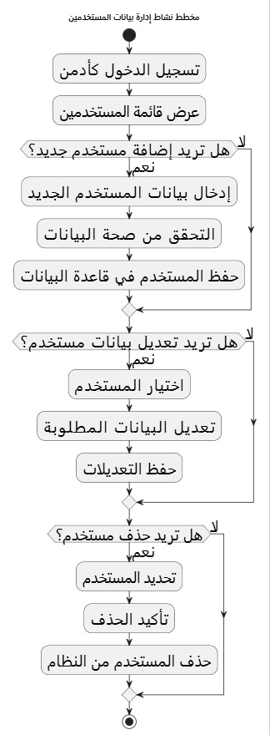

3.4.2 Activity Diagram of View system settings:
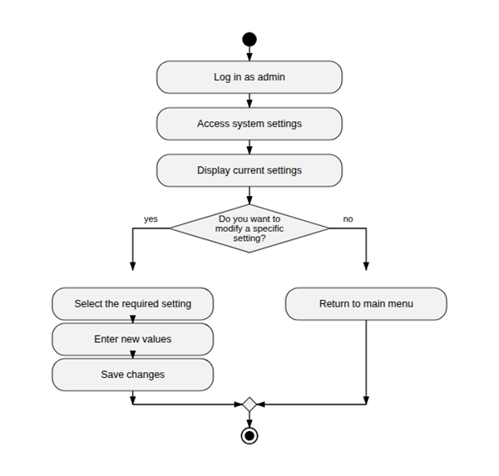

3.4.3 Activity Diagram of Monitor activity logs to keep track of system usage:

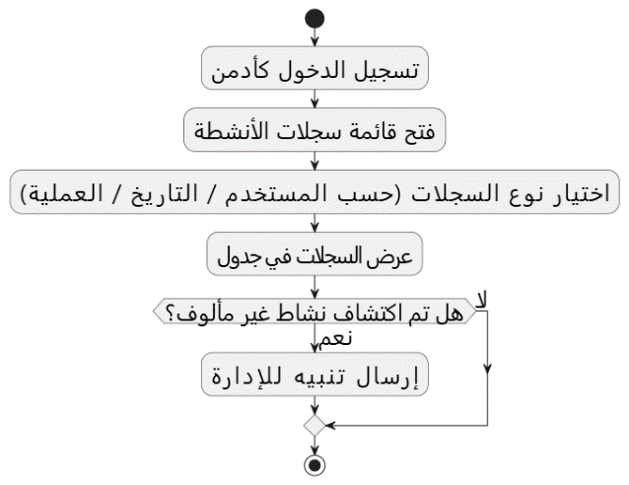

3.4.4 Activity Diagram of Change user account status (Active/Freeze):

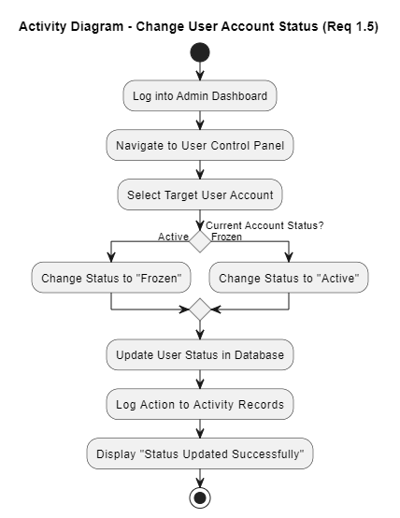

3.4. 5Activity Diagram of View general system statistics:

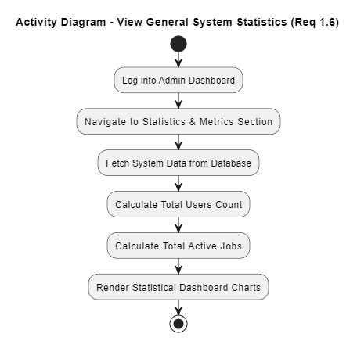

3.4.6 Activity Diagram of Create production and profit reports based on available data:
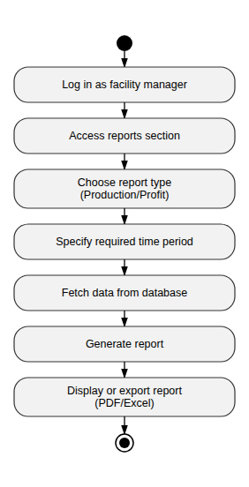

3.4.7 Activity Diagram of Plan and schedule Resources(food/fuel):
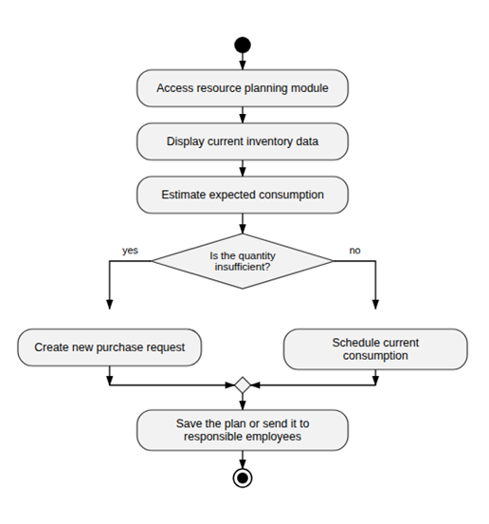

3.4.8 Activity Diagram of Request feed from the food supplier:

3.4.9 Activity Diagram of Request vaccines and medicines from the veterinarian:

3.4.10 Activity Diagram of Request equipment from the equipment supplier:

3.4.11 Activity Diagram of Send new purchase orders to suppliers:

3.4.12 Activity Diagram of Assign a new worker:

3.4.13 Activity Diagram of Track and analyze performance data to identify improvement opportunities and make strategic decisions:
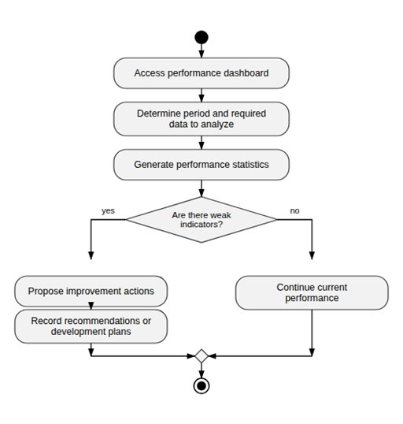

3.4.14 Activity Diagram of Send a recommendation to improve activity logs:

3.4.15 Activity Diagram of Send a recommendation to improve production (feed quantity – number of eggs produced):

3.4.16 Activity Diagram of Send a recommendation to improve facility resource utilization:

3.4.17 Activity Diagram of Set minimum inventory to alert the system when feed or fuel is low:
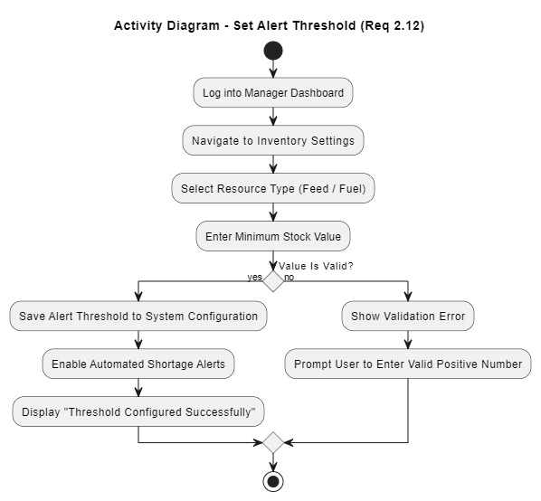

3.4.18 Activity Diagram of Review the annual archive of previous facility data:
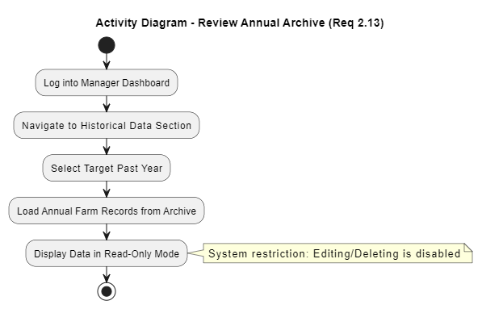

3.4.19 Activity Diagram of Recording veterinary examinations for individual and group cases:
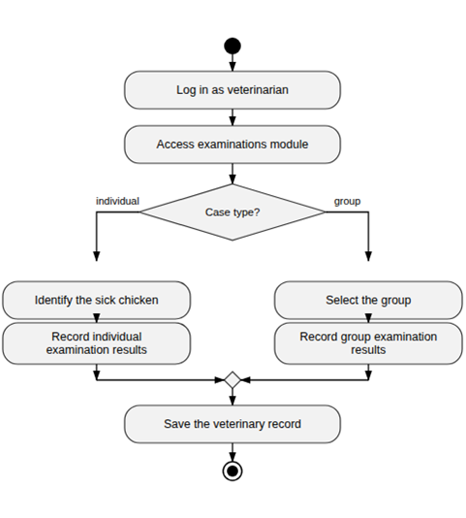

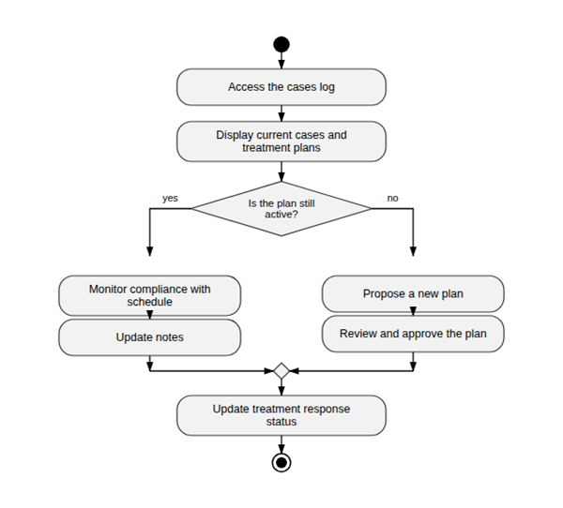
3.4.20 Activity Diagram of Follow-up of prevention and treatment plans:

3.4.21 Activity Diagram of Providing recommendations to improve the healthy environment within the facility:
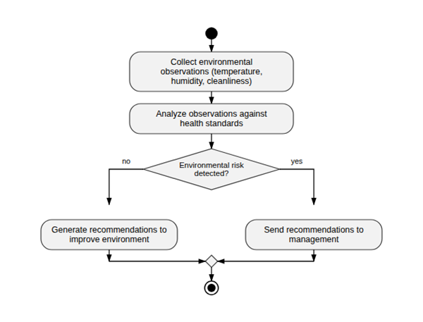

3.4.22 Activity Diagram of Providing specialized feeding plans to ensure the health and proper growth of poultry:

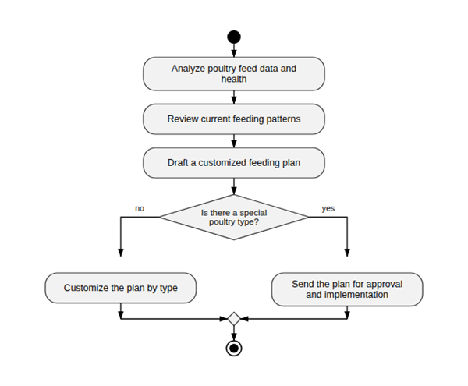

3.4.23 Activity Diagram of Displaying and printing the reports log:

3.4.24 Activity Diagram of Recording the daily mortality rate of birds

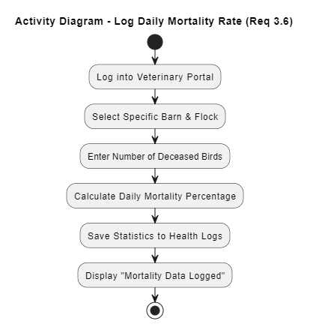

3.4.25 Activity Diagram of Printing and exporting proposed “prescriptions” to send to the manager or suppliers:
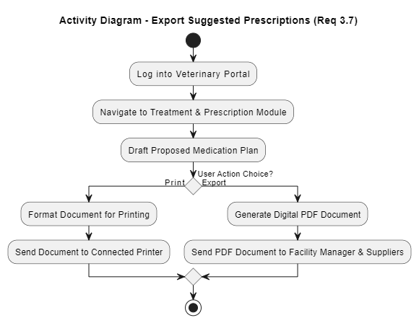

3.4.26 Activity Diagram of Recording daily poultry feeding data:

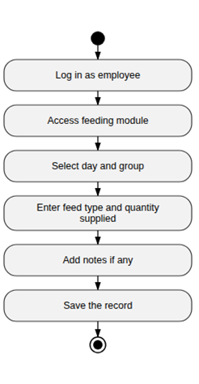

3.4.27 Activity Diagram of Report abnormalities using simple forms:
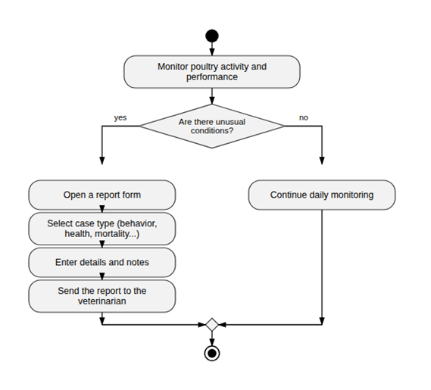

3.4.28 Activity Diagram of Updating the facility's cleanliness status:

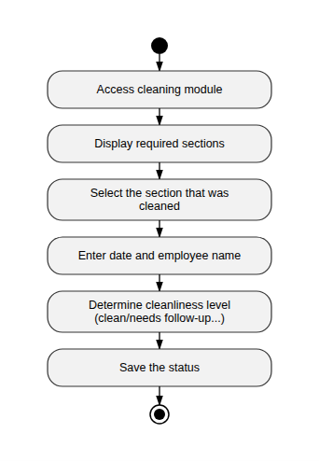

3.4.29 Activity Diagram of Assisting with sorting and packing operations when preparing poultry for sale:
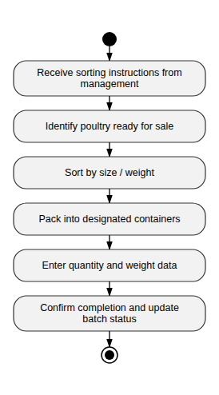

3.4.30 Activity Diagram of Viewing and printing sorting and packing operations:

3.4.31 Activity Diagram of Viewing and printing reports from the suppliers and the veterinarian:

3.4.32 Activity Diagram of Edit reports received from the suppliers and the veterinarian:

3.4.33 Activity Diagram of Record daily attendance and departure times:
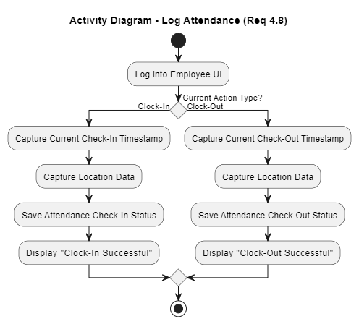

3.4.34 Activity Diagram of Viewing the daily tasks schedule assigned by management:

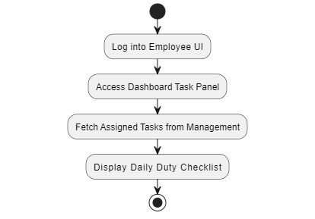

3.4.35 Activity Diagram of Adding details of the food items supplied (quantity/quality):

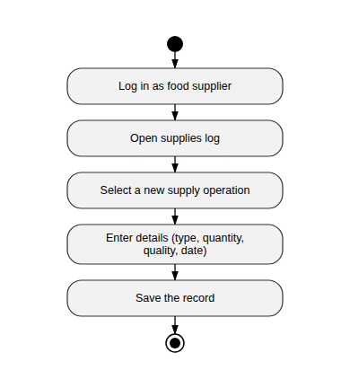

3.4.36 Activity Diagram of Submitting direct quotations via the system:
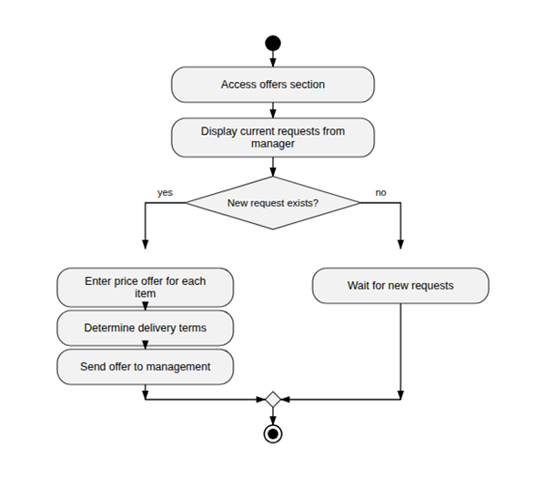

3.4.37 Activity Diagram of Edit and delete quotations:

3.4.38 Activity Diagram of Update the status of previous orders (Delivered/Not Delivered):
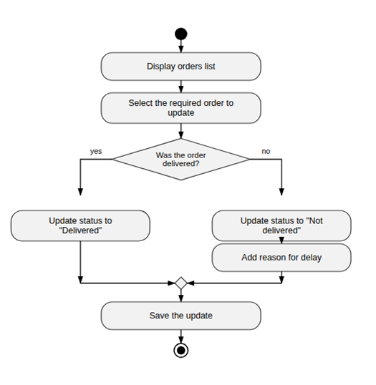

3.4.39 Activity Diagram of Provide reports on food consumption:

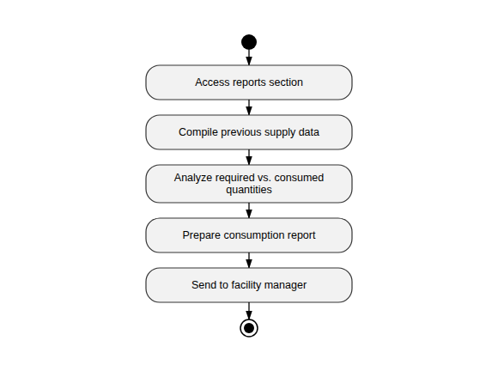

3.4.40 Activity Diagram of Editing, deleting and printing food consumption reports:

3.4.41 Activity Diagram of Updating the supplier’s profile and contact information:
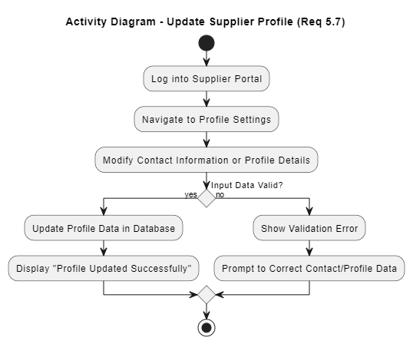

3.4.42 Activity Diagram of Viewing the history of previous quotations for reference:

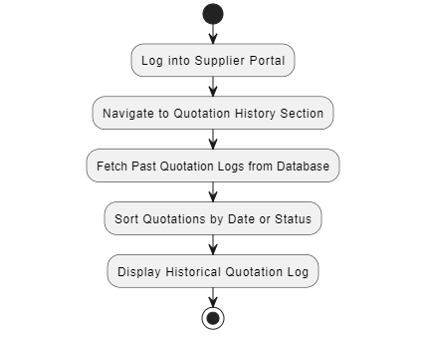

3.4.43 Activity Diagram of Recording the amount of fuel supplied in each operation:
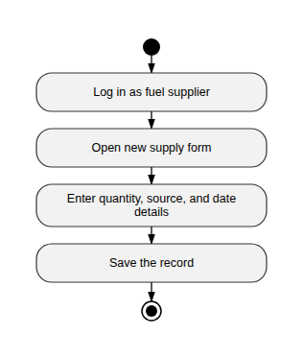

3.4.44 Activity Diagram of Report any delivery problem:

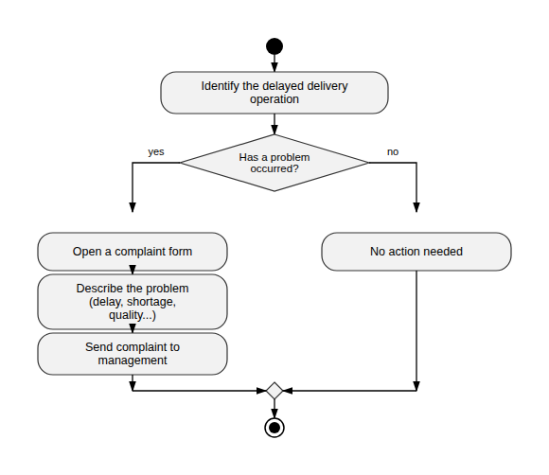

3.4.45 Activity Diagram of Submitting periodic reports on fuel consumption:
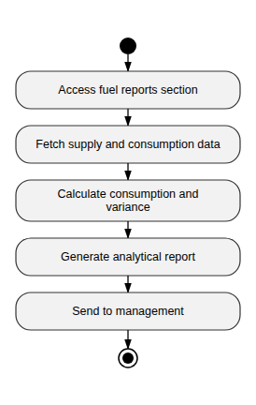

3.4.46 Activity Diagram of Providing recommendations to improve fuel efficiency and reduce costs:
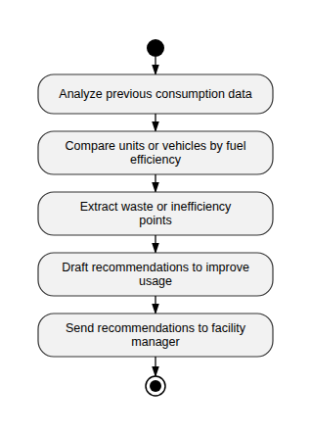

3.4.47 Activity Diagram of Editing, deleting and printing fuel status reports:

3.4.48 Activity Diagram of Updating availability dates and delivery times available:
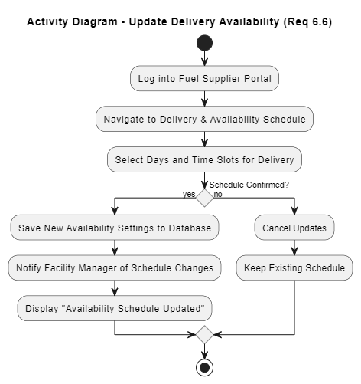

3.4.49 Activity Diagram of Displaying financial invoices received and related to delivered shipments:
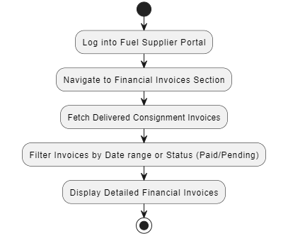

3.5 Table of Actors and Use Cases:
Use cases | Subject
Manage user data (add/modify/delete) - View system settings - Monitor activity logs to keep track of system usage - Change user account status (Active/Freeze) - View general system statistics. | System Admin
Create production and profit reports based on available data - Plan and schedule Resources(food/fuel) - Send new purchase orders to suppliers - Track and analyze performance data to identify improvement opportunities and make strategic decisions - Request feed from the food supplier - Request vaccines and medicines from the veterinarian - Request equipment from the equipment supplier - Assign a new worker - Send a recommendation to improve activity logs - Send a recommendation to improve production (feed quantity – number of eggs produced) - Send a recommendation to improve facility resource utilization - Set minimum inventory to alert the system when feed or fuel is low - Review the annual archive of previous facility data. | Facility Manager
Recording daily poultry feeding data - Report abnormalities using simple forms - Updating the facility's cleanliness status - Assisting with sorting and packing operations when preparing poultry for sale - Viewing and printing sorting and packing operations - Viewing and printing reports from the suppliers and the veterinarian - Edit reports received from the suppliers and the veterinarian - Record daily attendance and departure times - Viewing the daily tasks schedule assigned by management. | Employee
Recording veterinary examinations for individual and group cases - Follow-up of prevention and treatment plans - Providing recommendations to improve the healthy environment within the facility - Providing specialized feeding plans to ensure the health and proper growth of poultry - Displaying and printing the reports log - Recording the daily mortality rate of birds - Printing and exporting proposed “prescriptions” to send to the manager or suppliers. | Veterinarian
Adding details of the food items supplied (quantity/quality) - Submitting direct quotations via the system - Update the status of previous orders (Delivered/Not Delivered) - Edit and delete quotations - Provide reports on food consumption to determine future quantities required - Editing, deleting and printing food consumption reports - Updating the supplier’s profile and contact information - Viewing the history of previous quotations for reference. | Food Supplier
Recording the amount of fuel supplied in each operation - Report any delivery problem - Submitting periodic reports on fuel consumption - Providing recommendations to improve fuel efficiency and reduce costs - Editing, deleting and printing fuel status reports - Updating availability dates and delivery times available - Displaying financial invoices received and related to delivered shipments. | Fuel Supplier

3.6 Use Case Diagram:
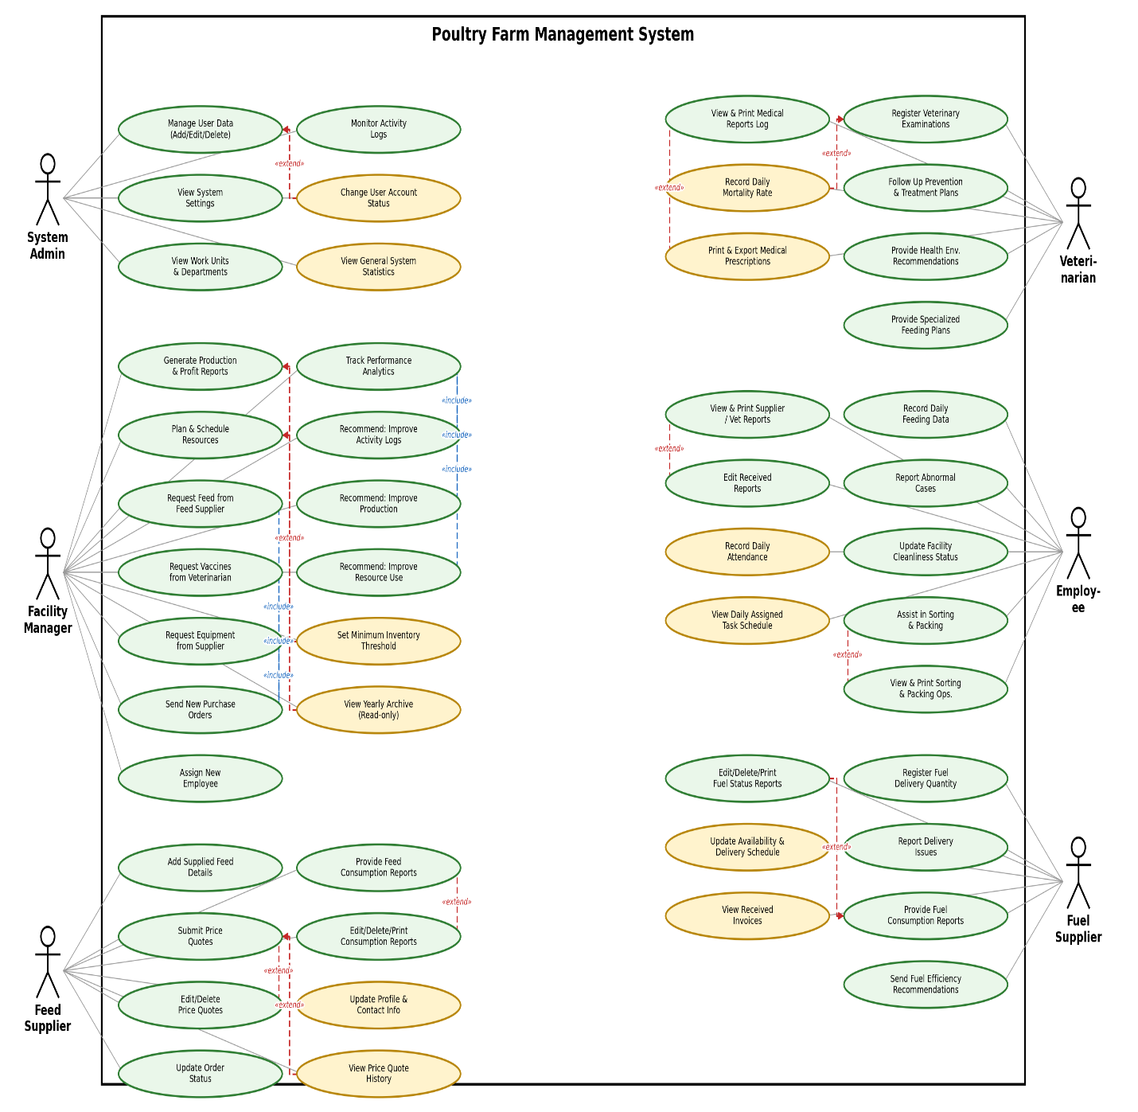

3.7 Textual Description of Use Cases:

3.7.1 Use Case Diagram for System Admin:

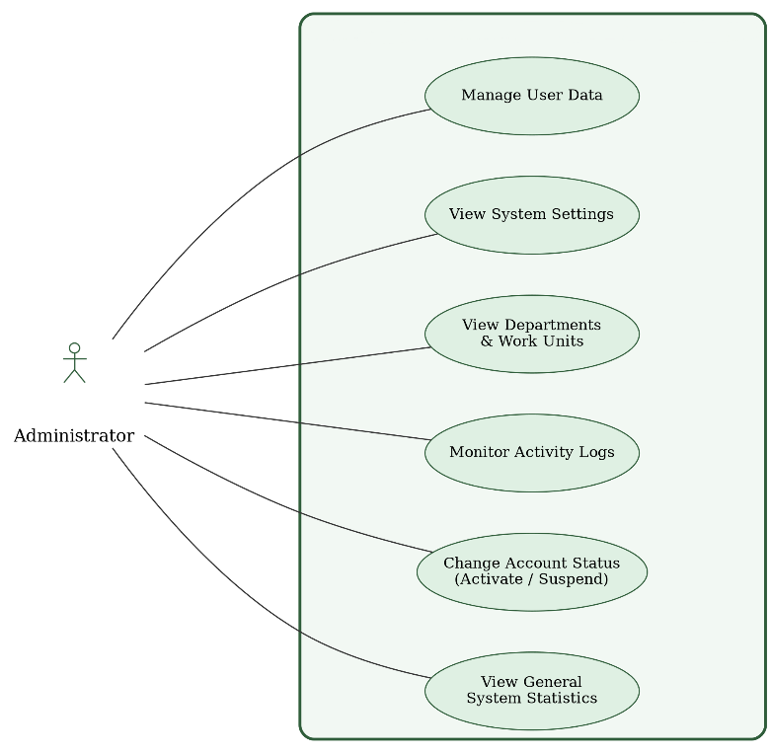

Text Description of system admin use cases:
Uc-01 | Requirement ID
Manage user data (add/modify/delete) | Description:
Admin System | Actors:
The user must be registered with the system as an admin.  The admin must have successfully logged in to the system.  The admin must have the authority to manage the users. | Prerequisites:
The user database is updated in accordance with the process performed (add,  modify, delete).  A pass/fail message is displayed for the process.  The process is recorded in the activity logs (logs) for tracking purposes. | Subsequent Conditions:
The admin logs in to the system  From the main menu, select "Manage Users"  The system displays a list of all existing users  The admin chooses one of the following options (Add, Delete, Edit)  The admin chooses the user who wants to manage their data  Adds, modifies, or deletes as he wants | Main Flow:

1: Use Case Description of Manage user data (add/modify/delete)

2: Use Case Description of View system settings

Uc-02 | Requirement ID
View system settings | Description:
Admin System | Actors:
The user must be registered with the system as an admin.  The admin must have successfully logged in to the system.  The system must be connected to the database.  The admin has access to the system settings. | Prerequisites:
New edits are saved in the database.  System settings are updated immediately or upon reboot (depending on the nature of the system).  Amendments are recorded in the system logs for tracking purposes.  Notify the admin of the success or failure of the process. | Subsequent  Conditions:
- The admin logs in to the system.  - From the main menu, select System Settings.  - Current settings (e.g. sections, work units...) are displayed.  - The admin chooses what he wants to modify: (Modify the name of a  department or unit - add a new section - delete an unused section).  - It makes the required adjustments.  - Press Save.  - The system validates the entered data.  - If the data is correct:  - They are saved in the database.  - A notification appears that the operation has been successful.  - Changes are logged in the system log. | Main Flow:
Uc-03 | Requirement ID
Monitor activity logs to keep track of system usage | Description:
Admin System | Actors:
The admin must have logged in to the system successfully.  Activity logs must be saved in the system (continuously or periodically).  The admin must have access to the "Activity Logs" page. | Prerequisites:
The admin can view the activities that have taken place within the system (login,  modify data, delete, add... etc.).  No data in the system is modified by the rendering process.  It is recorded that the admin has viewed the logs (for security purposes, if  necessary). | Subsequent  Conditions:
The admin logs in to the system.  From the main menu, select "Activity Logs"  The system displays a list of records in chronological order (most recent first),  including:  Username.  Type of operation (add, delete, modify, enter...).  Time and date.  IP address if available.  Administrators can use filters to sort records:  By date.  Depending on the user.  Depending on the type of operation.  The admin browses the logs as needed.  Details are displayed without any modification to the records | Main Flow:

3: Use Case Description of monitoring activity logs to follow up on system usage
4: Use Case Description of Change user account status (Active/Freeze)

Uc-04 | Requirement ID
Change user account status (Active/Freeze) | Description:
Admin System | Actors:
1. The user must be registered in the system as an Admin.  2. The Admin must be successfully logged into the system.  3. The system must be properly connected to the database.  4. The Admin must have the authority to access the User Management screen. | Prerequisites:
1. The new account status (Active / Frozen) is immediately saved in the database.  2. The access permission of the target user is updated at the exact same moment.  3. This operation is recorded in the System Logs for monitoring and security  purposes.  4. A prompt notification appears to the Admin confirming the success or failure of  the operation. | Subsequent  Conditions:
1. The Admin logs into the system.  2. From the main menu, the Admin selects the "User Management" tab.  3. The system displays a table containing the list of users and their current account statuses.  4. The Admin clicks on the (Activate/Freeze) button located next to the relevant user's name.  5. The system validates the request and sends the modification to the database.  6. If the data is valid:  * The new changes are saved in the database.  * A notification appears on the screen confirming the success of the operation.  7. The changes are automatically recorded in the System Log. | Main Flow:

Uc-05 | Requirement ID
View general system statistics | Description:
Admin System | Actors:
1. The user must be registered in the system as an Admin.  2. The Admin must be successfully logged into the system.  3. The system must be connected to the database and capable of reading its tables. | Prerequisites:
- The total numbers of users and jobs are displayed in a visual and  organized manner.  - No modification or deletion is made in the database (Read and display  operation only). | Subsequent  Conditions:
1. The Admin logs into the system.  2. The Admin navigates to the main Dashboard.  3. The system automatically and immediately requests the statistics from the  database.  4. The server calculates the total counts (number of workers, doctors, merchants,  and active accounts).  5. The server returns the summarized statistical data to the user interface.  6. The total numbers are accurately and clearly displayed inside attractive  statistical cards on the Dashboard. | Main Flow:

5: Use Case Description of View general system statistics

3.7.2 Use Case Diagram for Facility Manager:
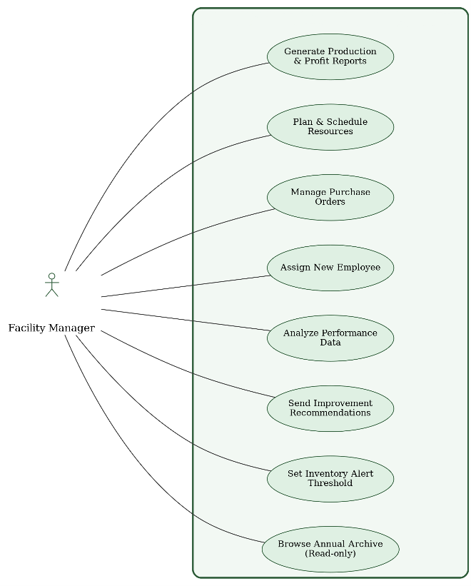

Textual Description of Facility Manager Use Cases:

M-01 | Requirement ID
Create production and profit reports based on available data | Description:
Facility Manager | Actors:
- The user must be registered as an "admin".  - The manager must have logged in to the system successfully.  - Activity logs must be saved in the system (continuously or periodically).  - The manager must have access to the "Activity logs" page | Prerequisites:
- The manager can view the activities that have taken place within the system (login, modify data, delete, add... etc.).  - No data in the system is modified by the rendering process.  - It is recorded that the admin has viewed the logs (for security purposes, if necessary). | Subsequent Conditions:
- The manager logs in to the system.  - From the main menu, select "Activity Logs."  - The system displays a list of records in chronological order (most recent first), including:  - Username.  - Type of operation (add, delete, modify, enter...).  - Time and date.  - IP address if available.  - Manager can use filters to sort records:  - By date.  - Depending on the user.  - Depending on the type of operation.  - The manager browses the logs as needed.  - Details are displayed without any modification to the records | Main Flow:
6: Use Case Description of Create production and profit reports based on available data
7: Use Case Description of Plan and schedule Resources(food/fuel)

M-02 | Requirement ID
Plan and schedule Resources(food/fuel) | Description:
Facility Manager | Actors:
Such as food (poultry feed) and fuel.  The system must be up-to-date with supplier information and the ability to add or modify suppliers.  Estimates of poultry food and fuel needs based on the number and age stages of poultry.  Such as the number of poultry, the area of the barns, and other details related to the agricultural environment.  There should be a start date for the chart or timeline for each operation (such as the start date of the day or the specified period of supply). | Prerequisites:
Food and fuel scheduling should be done based on actual need.  The database must be modified to update the available amounts of resources and scheduling dates.  The facility manager should receive a notification when resources are running out or when new payments need to be received.  A report on food and fuel consumption should be generated and aligned with expectations.  Poultry food and fuel needs in the future should be determined based on current consumption | Subsequent Conditions:
- The facility manager enters the poultry data such as (the number of poultry, barns, and their daily needs of food and fuel).  - The system calculates the amount of food and fuel required based on the number of poultry and its needs.  - The system creates a plan to schedule supplies of food and fuel according to the calculated needs.  - Supplier details such as (supply time and material prices) are entered.  - A notification will be sent to the facility manager of the date of receipt of the required materials or supplies.  - The system provides periodic reports to the facility manager on (the amount of resources consumed, suppliers and delivery dates). | Main Flow:

M-03 | Requirement ID
Send new purchase orders to suppliers | Description
Facility Manager | Actors
The system should have up-to-date information about the suppliers and merchants to whom orders can be sent.  There must be a warehouse or database that contains information on the available inventory in the facility (e.g., food, feed, fuel, etc.).  Accurate details of the facility's needs for the materials you wish to purchase (e.g. quantities ordered, type of materials, delivery dates) must be entered.  The facility manager must have the necessary powers to send purchase orders, whether through the system or the merchant communication mechanism.  There must be a approved budget for procurement so that orders can be executed within the available budget. | Prerequisites:
- Food and fuel scheduling should be done based on actual need.  - The database must be modified to update the available amounts of resources and scheduling dates.  - The facility manager should receive a notification when resources are running out or when new payments need to be received.  - A report on food and fuel consumption should be generated and aligned with expectations.  - Poultry needs for food and fuel in the future should be determined based on current consumption. | Subsequent Conditions
- The facility manager enters poultry data, such as the number of poultry, barns, and their daily food and fuel needs.  - The system calculates the amount of food and fuel required based on the number of poultry and its needs.  - The system creates a plan to schedule supplies of food and fuel according to the calculated needs.  - Supplier details are entered, such as supply time and material prices.  - A notification will be sent to the facility manager of the date of receipt of the required materials or supplies.  - The system provides periodic reports to the facility manager on the amount of resources consumed, suppliers and delivery dates | Main Flow
8: Use Case Description of Send new purchase orders to suppliers

9: Use Case Description of Track and analyze performance data to identify improvement opportunities and make strategic decisions

M-04 | Requirement ID
Track and analyze performance data to identify improvement opportunities and make strategic decisions | Description
Facility Manager | Actors
The system must contain accurate and up-to-date data on the performance of the facility, such as:  - Poultry growth rates.  - Feed consumption.  - Production rates (e.g. eggs or meat).  - Operational costs (e.g., food, labor, fuel, etc.)  - Data on losses or diseases.  The key performance indicators to be analyzed such as production rates, costs, returns, losses, etc. should be identified.  There should be pre-defined criteria or targets (such as monthly or annual targets) to compare actual performance.  The manager must have the necessary tools in the system to view and analyze the data, such as graphs, interactive tables, and analytical reports.  The facility manager must have the appropriate authority to access and analyze this data. | Prerequisites
- A report with a comprehensive performance analysis should be created based on the data entered, identifying areas that need improvement.  - Potential opportunities to improve processes or increase efficiency, whether in resource consumption or production optimization, should be identified.  - Based on the analysis, strategic decisions are made such as:  - A change in production practices.  - Edit the resource scheduling.  - Improve procurement or supply strategies.  - Future action plans are adjusted based on the findings from the analysis.  - A brief report or notice must be sent to the parties involved (such as managers or operational teams) to implement the new changes or strategies. | Subsequent Conditions

10: Use Case Description of Request feed from the food supplier

Requirement ID | M-05
Description | Request feed from the food supplier
Actors | Manager
Preconditions | 1. Manager is logged in and authorized.  2. Current feed inventory is recorded.  3. Minimum stock level is defined.
Postconditions | 1. New purchase order created with status "Pending Send".  2. Order history updated.  3. Inventory updated after supplier confirmation
Main Flow | 1. Manager selects "New Feed Request".  2. System shows recommended quantity.  3. Manager enters quantity and selects supplier.  4. System generates order invoice.  5. Manager clicks "Send Order".  6. System sends order to supplier.  7. Confirmation shown and order logged.
Alternative Flow | Send fails → Save as draft with retry option.

Requirement ID | M-06
Description | Request vaccines and medicines from the veterinarian
Actors | Manager
Preconditions | 1. Manager is logged in and authorized.  2. Current medicine inventory is recorded.  3. Minimum stock level is defined or manager  4. List of available medicines and Vet suppliers is maintained in the system.
Postconditions | 1. New medicine purchase order created with status "Pending Send".  2. Order history updated.  3. Inventory updated after Vet confirmation.  4. Notification sent to manager upon order confirmation.
Main Flow | 1. Manager selects "Medicine Management" → "New Medicine Order".  2. System displays current medicine stock and recommended reorder quantities.  3. Manager selects required medicines (type, quantity, dosage form if applicable).  4. Manager selects the Vet (supplier) from the list. 5. System generates an order summary with: medicine names, quantities, unit prices, total cost, requested delivery date.  6. Manager reviews and clicks "Send Order".  7. System sends the order to the Vet (via API, email, or dedicated interface)  8. System shows confirmation "Order sent successfully" and logs the request with timestamp.  9. System updates expected delivery status
Alternative Flow | Send fails → Save as draft with retry option.

11: Use Case Description of Request vaccines and medicines from the veterinarian

12: Use Case Description of Request equipment from the equipment supplier

Requirement ID | M-08
Description | Assign a new worker
Actors | Manager
Preconditions | Manager is logged in.
Postconditions | New employee is added to the system.
Main Flow | 1. Manager clicks "Add Employee".  2. Manager enters employee details (name, position).  3. Manager clicks "Save".  4. System saves employee and shows "Employee added successfully".
Alternative Flow | If employee email or phone already exists: System shows "Employee already  exists" and asks to use different details.

Requirement ID | M-07
Description | Request equipment from the equipment supplier
Actors | Manager
Preconditions | 1- Manager is logged in.  2- Tool inventory is recorded.
Postconditions | Order is saved and sent to supplier.
Main Flow | 1. Manager clicks "Order Tools".  2. System shows list of tools.  3. Manager selects tool and enters quantity.  4. Manager clicks "Submit Order".  5. System sends order to supplier.  6. System shows "Order sent".
Alternative Flow | Send fails → Save as draft with retry option.
13: Use Case Description of Assign a new worker

Requirement ID | M-09
Description | Send a recommendation to improve activity logs
Actors | Manager
Preconditions | 1- Manager is logged in.  2- Activity records exist in the system
Postconditions | 1- Recommendation is saved and sent.
Main Flow | 1. Manager clicks "Send Recommendations".  2. Manager writes recommendation text.  3. Manager clicks "Submit".  4. System saves and sends recommendation.  5. System shows "Recommendation sent successfully".
Alternative Flow | If recommendation text is empty:  System shows "Please enter recommendation text" and asks manager to write something.
14: Use Case Description of Send a recommendation to improve activity logs

Requirement ID | M-10
Description | Send a recommendation to improve production (feed quantity – number of eggs produced)
Actors | Manager
Preconditions | 1- Manager is logged in.  2- Productivity data (food quantity, egg count) is available.
Postconditions | Recommendation is saved and sent.
Main Flow | 1. Manager clicks "Send Productivity Recommendations".  2. Manager selects type (Food Quantity or Egg Count).  3. Manager writes recommendation text.  4. Manager clicks "Submit".  5. System saves and sends recommendation.  6. System shows "Recommendation sent successfully".
Alternative Flow | If recommendation text is empty: System shows "Please enter recommendation  text" and asks manager to write something.

15: Use Case Description of Send a recommendation to improve production (feed quantity – number of eggs produced)

Requirement ID | M-11
Description | Send a recommendation to improve facility resource utilization
Actors | Manager
Preconditions | Manager is logged in.  Resource consumption data is available.
Postconditions | Recommendation is saved and sent.
Main Flow | 1. Manager clicks "Send Resource Recommendations".  2. Manager writes recommendation text.  3. Manager clicks "Submit".  4. System saves and sends recommendation.  5. System shows "Recommendation sent successfully".
Alternative Flow | If recommendation text is empty: System shows "Please enter recommendation  text" and asks manager to write something.
16: Use Case Description of Send a recommendation to improve facility resource utilization

17: Use Case Description of Set minimum inventory to alert the system when feed or fuel is low

M-12 | Requirement ID
Set minimum inventory to alert the system when feed or fuel is low | Description:
Facility Manager | Actors:
1. The user must be registered with Facility Manager permissions.  2. The Manager must be successfully logged into the system.  3. The target material (such as feed or fuel) must be previously defined in the  inventory. | Prerequisites:
1. The new minimum threshold value is saved in the database.  2. The system starts monitoring inventory quantities and automatically comparing them with the new value.  3. Warning alerts are triggered and sent to the Manager as soon as the inventory  reaches or falls below this limit. | Subsequent  Conditions:
1. The Manager logs into the system.  2. From the side menu, the Manager selects the "Resource and Inventory  Management" page.  3. The system displays a list of available materials and their current quantities.  4. The Manager enters the numerical value for the minimum limit in the designated field next to the required material.  5. The Manager clicks on the "Save" button.  6. The system verifies that the entered value is valid (a positive number).  7. If the data is valid:  * The new minimum limit is saved in the database.  * A notification message appears confirming the success of the save operation.  8. The system activates automatic monitoring and sends visual warnings when  quantities decrease on the field. | Main Flow:

M-13 | Requirement ID
Review the annual archive of previous facility data | Description:
Facility Manager | Actors:
1. The Manager must be successfully logged into their account.  2. Locked records or archived data for previous years must exist in the database. | Prerequisites:
1. Historical reports and data for the selected year are accurately displayed.  2. Data is displayed in a "Read-Only" format to protect the historical archive from  any accidental modification or deletion. | Subsequent  Conditions:
1. The Manager logs into the system.  2. The Manager selects the "Annual Archive" tab from the menu.  3. The system displays a drop-down list containing the years that were previously archived.  4. The Manager selects the year they wish to review and browse its data.  5. The system queries and retrieves the locked financial, production, and health  records for that specific year.  6. The historical data and tables are displayed to the Manager for viewing and  comparison without providing any edit buttons. | Main Flow:
18: Use Case Description of Review the annual archive of previous facility data

3.7.3 Use Case Diagram for Veterinarian:
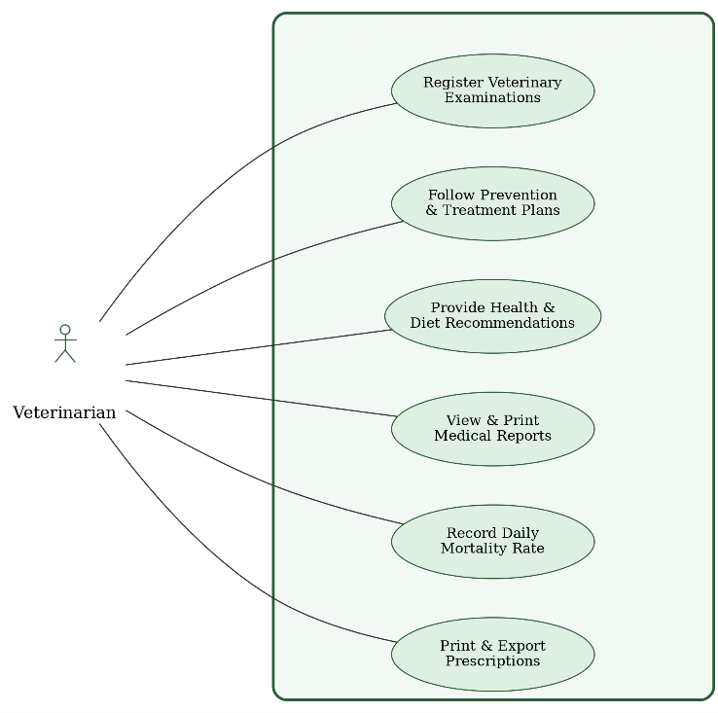

Textual Description of Veterinarian Use Cases:
Requirement ID | Vet-01
Description | Recording veterinary examinations for individual and group cases
Actors | Veterinarian
Pre-conditions | The veterinarian must have an active account with permission to enter and modify examination data.  Poultry data (groups or individuals) must be pre-registered in the system with identification codes.  The system must contain a form for entering veterinary examination data for both individual and group cases.  The system must support distinguishing between group cases (e.g., an entire flock) and individual cases (a single bird or small group).  There must be an updatable list of common diseases or symptoms to facilitate accurate diagnosis entry by the veterinarian.
Post-conditions | - All examination details are saved in the database for future reference.  - The examination is automatically linked to the case or flock in their health record.  - If a contagious disease is detected, the system issues an alert to the facility manager or relevant teams.  - A medical report for the individual or group case can be generated, including symptoms, examination findings, recommended treatment, and follow-up date.  - Based on the type of disease, the system can suggest a treatment plan and schedule for follow-up visits.
Main Flow: | 1. Determine whether the case is individual (bird/small group) or collective (entire flock).  2. Select the sick poultry via an identification number or group name.  3. Enter examination details:  - Date and time  - Observed symptoms  - Tests performed  - Clinical observations  4. Select the disease or suspected condition from a list or enter it manually.  5. Prescribe medications, isolation, or any preventive or therapeutic measures.  6. Save the data in the system and update the medical record for the bird or flock.  - 7. Send a notification to the manager or health supervisor in case of a critical or communicable condition.
19: Use Case Description of Recording veterinary examinations for individual and group cases

Requirement ID | Vet-02
Description | Follow-up of prevention and treatment plans
Actors | Veterinarian
Pre-conditions | - The veterinarian must be registered in the system with access permissions.  - There must be barns registered in the system.  - There must be a pre-recorded treatment or prevention plan (either prepared by the veterinarian or the barn supervisor).  - Availability of vital and health data for poultry (temperature, weight, symptoms, etc.).
Post-conditions | - A new follow-up for the flock's health condition has been recorded.  - The prevention or treatment plan has been updated (if necessary).  - Relevant parties have been notified of changes (e.g., field workers, barn supervisor).  - A time-stamped record of modifications has been maintained for tracking and future review.
Main Flow | 1. The veterinarian logs into the system.  2. Navigates to the "Prevention and Treatment Plans" section.  3. Selects the barn or flock to follow up on.  4. Reviews the approved prevention or treatment plan.  5. Updates the poultry health status based on daily or periodic examinations.  6. Adds medical notes or instructions (e.g., changing treatment, adjusting dosage, suggesting additional tests).  7. Saves the modifications in the system.  8. Modifications are recorded and notifications are sent to supervisors or relevant workers (if required).
Alternative Flow | - No treatment plan recorded yet: The veterinarian adds a new plan before proceeding.  - Flock data not updated: A warning message appears for the veterinarian, who can request the supervisor to update the data or do it themselves.  - Veterinarian not authorized to access a specific barn: An access denial notification appears, prompting a request to the administrator to modify permissions.
20: Use Case Description of Follow-up of prevention and treatment plans

Requirement ID | Vet-03
Description | Providing recommendations to improve the healthy environment within the facility
Actors | Veterinarian
Pre-conditions | - The facility manager has an account and access permission to the system.  - Environmental and health data are recorded in the system (e.g., air quality, humidity, ventilation, temperature, barn cleanliness, recorded health conditions).  - Periodic or real-time reports from various departments are available (e.g., veterinarian reports, supervisor reports, environmental sensor system if available).
Post-conditions | - New environmental recommendations have been recorded, linked to a specific date and barn or department.  - Relevant teams have been notified of the required recommendations for implementation.  - The recommendations are now part of the environmental improvement record and can be tracked later.  - The recommendations can be used in performance reports or facility quality reviews.
Main Flow | 1. The facility manager logs into the system.  2. Navigates to the "Environmental Recommendations" section.  3. Reviews the health and environmental data for the barns or various departments in the facility.  4. Analyzes the indicators or relies on system-generated reports.  5. Identifies areas needing improvement (e.g., ventilation, cleanliness, lighting, etc.).  6. Enters the appropriate recommendations in the system (manually or using ready-made templates).  7. Saves the recommendations, which are then sent to the relevant parties (supervisors, technicians, veterinarian, etc.).  8. The recommendations are recorded as a reference log.
Alternative Flow: | - No updated environmental data: The system displays a warning and asks the manager to request data updates from the relevant team or wait.  - Manager requests an automated analytical report: The system generates preliminary recommendations based on recorded data (if smart analysis or AI technology is available in the system).  - Sent recommendations require approval: Recommendations are saved in a "pending" status and sent to the authorized party for review and approval (e.g., veterinarian or a small administrative board within the system).
21: Use Case Description of Providing recommendations to improve the healthy environment within the facility

Requirement ID | Vet-04
Description | Providing specialized feeding plans to ensure the health and proper growth of poultry
Actors | Veterinarian
Pre-conditions | The facility manager must be registered and authenticated in the system.  Poultry data (age, species, health condition, production goal) must be recorded in the system.  A database containing nutritional values and feed components must be available.
Post-conditions | A specialized dietary plan is created based on specified criteria.  The plan is saved within the relevant flock's record.  The plan can be printed or shared with field or farm personnel.
Main Flow | 1. The facility manager logs into the system.  2. Selects "Dietary Plan Management".  3. Specifies the target flock (or a specific poultry group).  4. Defines the following criteria:  - Type (layer / broiler)  - Age stage  - Goal (growth / fattening / egg production)  - Special environmental or health conditions if any  5. Clicks "Generate Dietary Plan".  6. The system analyzes the data and generates an appropriate dietary plan.  7. The system displays the proposed dietary plan in detail.  8. The manager can approve, modify, or export the plan.
Alternative Flow | - Alternative 1 – Flock data not available: If flock data is unavailable, the system displays a warning and requests it be entered first.  - Alternative 2 – Incompatible input criteria: If the manager enters incompatible data (e.g., an age that does not match the plan type), the system displays an error message requesting correction.  - Alternative 3 – Plan generation fails due to insufficient nutritional data: The system displays a warning about missing nutritional components and suggests adding them to the database or using a default plan.

Requirement ID | Vet-05
Description | Displaying and printing the reports log
Actors | Veterinarian
Preconditions | 1- Vet is logged in.  2- Report records existing the system
Postconditions | 1- Report is displayed and/or printed.
Main Flow | 1. Vet clicks "View Reports".  2. System shows list of available reports.  3. Vet selects a report.  4. System displays the report.  5. Vet clicks "Print".  6. System sends report to printer.
Alternative Flow | If no reports exist: System shows "No reports available" message.
22: Use Case Description of Providing specialized feeding plans to ensure the health and proper growth of

23:Use Case Description of Displaying and printing the reports log
Vet-06 | Requirement ID
Recording the daily mortality rate of birds | Description:
Veterinarian | Actors:
1. The Veterinarian must be successfully logged into the veterinarian account.  2. The target barn or coop must be registered and defined in the system. | Prerequisites:
1. The number of dead birds is saved and linked to the specific barn and the  current date.  2. The total number of live birds in the barn is automatically updated based on this input.  3. The figure is directly reflected on the chart to track the general health curve of  the farm. | Subsequent  Conditions:
1. The Veterinarian logs in and navigates to the medical examinations page.  2. The Veterinarian opens a new daily examination registration form for the barn.  3. The Veterinarian enters the number of mortality cases observed today in the  designated field.  4. The Veterinarian clicks on the "Save Record" button.  5. The system verifies the validity of the number and then programmatically  deducts it from the total flock of the barn.  6. If the data is valid:  * The record is saved in the database.  * A confirmation message appears stating that the operation was successful.  7. The health chart updates immediately to reflect the detected mortality rate. | Main Flow:
24: Use Case Description of Recording the daily mortality rate of birds

Vet-07 | Requirement ID
Printing and exporting proposed “prescriptions” | Description:
Veterinarian | Actors:
1. The Veterinarian must be present on the medical reports or examinations  screen.  2. A medical report or a registered examination case containing recommended  medications and dosages must exist. | Prerequisites:
1. Generating an official, organized, and formatted document containing  prescription details.  2. The process is performed locally in the browser without requiring any write or modify operations in the database. | Subsequent  Conditions:
1. The Veterinarian reviews the registered medical reports or examinations.  2. The Veterinarian selects the required case and clicks on the "Print Prescription" button.  3. The system automatically compiles the prescription data (doctor's name, date,  medication type, and dosages).  4. The system opens the standard print window of the web browser and operating system.  5. The Veterinarian instantly chooses either the paper print option or saves the  document as a PDF file.  6. The printed document is delivered to the management or merchants to secure  the required medications. | Main Flow:

25: Use Case Description of Printing and exporting proposed “prescriptions”

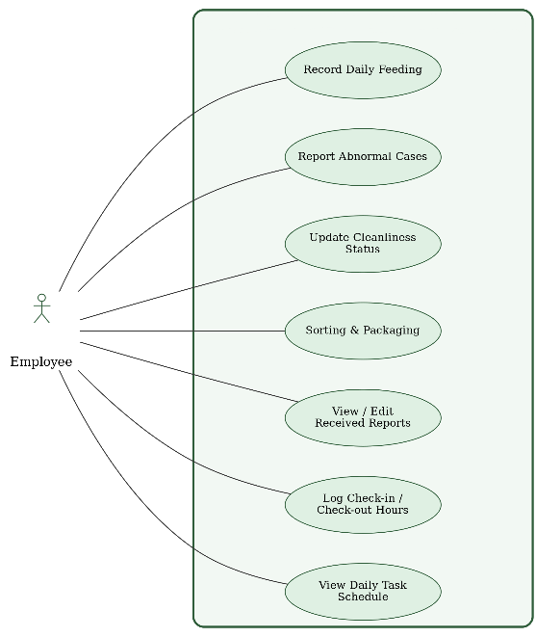
3.7.4 Use Case Diagram for Employee:

Textual Description of Employee Use Cases:
Requirement ID | Emp-01
Description | Recording daily poultry feeding data
Actors | Employee
Pre-conditions | - The employee must be registered and authorized to access the system.  - There must be a specified and approved feeding plan for each flock.  - The flock or barn for which data will be recorded must be identified.
Post-conditions | - Daily feeding data is saved in the system database.  - Data becomes available for reports or analysis by the manager or veterinarian.  - Data can be used to monitor compliance with the dietary plan and analyze performance.
Main Flow | 1. The employee logs into the system.  2. Selects "Record Daily Feeding" from the menu.  3. Specifies the target flock or barn.  4. Enters the following data:  - Date  - Type of feed provided  - Quantity (kg or ton)  - Number of meals or distribution times  - Notes (if any, e.g., feed rejection, distribution issues)  5. Reviews the entries and clicks "Save".  6. The system confirms successful recording and displays a confirmation message.
Alternative Flow | - Alternative 1 – No flock selected: The system displays a message: "Please select a flock first," and returns the user to the appropriate step.  - Alternative 2 – Incomplete or incorrect data: If the quantity or type is not entered, the system displays a warning and requests data completion.  - Alternative 3 – Feeding plan not available: The system displays a warning that the specified flock has no registered feeding plan and prevents recording until it is set up by the manager.
26: Use Case Description of Recording daily poultry feeding data

Requirement ID | Emp-02
Description | Report abnormalities using simple forms
Actors | Employee
Pre-conditions | - The employee must be registered in the system and have reporting permissions.  - Information about the flock or barn to be reported must exist in the system.  - An electronic reporting form must be available within the system (or mobile app) with the required fields.
Post-conditions | - The report is saved in the database as a note linked to the flock or location.  - An automatic notification is sent to the manager, veterinarian, or relevant authority.  - The report status can be tracked (processed, under action, closed).
Main Flow | 1. The employee logs into the system and selects "Abnormal Condition Report Form".  2. Specifies:  - The relevant flock or barn  - Type of condition (health, behavior, environmental, nutritional)  3. Enters condition details, such as:  - Description (e.g., sudden death, drop in feed consumption, unusual sound, high temperature)  - Date and time  - Photos or video (optional – if supported)  4. Clicks "Submit Report".  5. The system displays a confirmation message and generates a report tracking number.
Alternative Flow | - Alternative 1 – No flock or barn selected: The system displays a warning: "Please select a flock or barn first," and prevents submission.  - Alternative 2 – Incomplete data: If the description field is left empty, the system displays an error message and requires it to be filled before proceeding.  - Alternative 3 – Connection or save failure: The system displays an error message: "Unable to submit report. Check connection or try again later," and temporarily stores the report in offline mode (if supported).
27: Use Case Description of Report abnormalities using simple forms
Requirement ID | Emp-03
Description | Updating the facility's cleanliness status
Actors | Employee
Pre-conditions | - The employee is registered in the system.  - The employee has successfully logged in.
Post-conditions | - The new cleanliness status has been saved successfully.  It is now available for management and review.
Main Flow | 1. The employee logs into the system.  2. Navigates to the "Cleanliness Status" section.  3. Selects the relevant facility or department.  4. Specifies the status (Clean, Needs Cleaning, Cleaning in Progress, etc.).  5. Adds notes if applicable.  6. Clicks "Save".  7. The system displays a success message.
Alternative Flow | - Employee not registered / not authorized: A message appears: "You do not have permission."  - Network connection unavailable: A message appears: "Connection failed, please try again later."  - Incomplete or incorrect input: A warning appears to correct the required data.
28: Use Case Description of Updating the facility's cleanliness status

Requirement ID | Emp-04
Description | Assisting with sorting and packing operations
Actors | Employee
Pre-conditions | The employee is registered in the system.  The employee has successfully logged in.
Post-conditions | The employee's contribution to packaging has been recorded.  Data has been added to work and production reports.
Main Flow | 1. The employee logs into the system.  2. Navigates to the "Packaging Operations" section.  3. Specifies the type of packaging (eggs, poultry, feed, etc.).  4. Specifies the quantity or time period worked.  5. Adds notes (optional).  6. Clicks "Save".  7. A notification of successful recording appears.
Alternative Flow | - Employee not logged in: Access is denied and login is required.  - Required data not entered: A message appears: "Please fill in all required fields."  - Data save failure due to technical issue: A warning appears: "A technical error occurred, please try again later."
29: Use Case Description of Assisting with sorting and packing operations

Requirement ID | Emp-05
Description | Viewing and printing sorting and packing operations
Actors | Employee
Preconditions | 1- Employee is logged in.  2- Sorting and packing records exist.
Postconditions | Processes are displayed and/or printed.
Main Flow | 1. Employee clicks "View Sorting & Packing".  2. System shows list of sorting/packing tasks.  3. Employee selects a task.  4. System displays task details.  5. Employee clicks "Print".  6. System sends task details to printer.
Alternative Flow | If no tasks exist: System shows "No sorting or packing tasks available".
30: Use Case Description of Viewing and printing sorting and packing operations

31: Use Case Description of Viewing and printing reports from the suppliers and the veterinarian

Requirement ID | Emp-07
Description | Edit reports received from the suppliers and the veterinarian
Actors | Employee
Preconditions | - Employee is logged in.  - Reports from suppliers and vet exist.
Postconditions | Report is updated and saved in the system
Main Flow | 1. Employee clicks "View Reports".  2. System shows report sources (Suppliers, Vet)  3. Employee selects a source.  4. System shows list of reports.  5. Employee selects a report.  6. System displays the report.  7. Employee clicks "Edit".  8. Employee modifies report data.  9. Employee clicks "Save".  10. System saves changes and shows "Report updated successfully".
Alternative Flow | If report does not exist: System shows "Report not found" message

Requirement ID | Emp-06
Description | Viewing and printing reports from the suppliers and the veterinarian
Actors | Employee
Preconditions | - Employee is logged in.  - Reports from suppliers and vet exist.
Postconditions | Reports are displayed and/or printed
Main Flow | 1. Employee clicks "View Reports".  2. System shows report sources (Suppliers, Vet)  3. Employee selects a source.  4. System shows list of reports from that source. 5. Employee selects a report.  6. System displays the report.  7. Employee clicks "Print".  8. System sends report to printer.
Alternative Flow | If no reports exist: System shows "No reports available from this source".
32: Use Case Description of Edit reports received from the suppliers and the veterinarian

Emp-08 | Requirement ID
Record daily attendance and departure times | Description:
Employee | Actors:
1. The Employee must be registered in the system and have an active account.  2. The Employee must be successfully logged into their personal account. | Prerequisites:
1. Attendance and departure times are accurately logged and documented in the  timesheet table.  2. The visual state of the button changes in the user interface to prevent duplicate  recording on the same day.  3. This data is used later by management to calculate working hours and payrolls. | Subsequent  Conditions:
1. The Employee logs into the system, and the shift control buttons appear at the  top of the screen.  2. At the start of the shift, the Employee clicks the "Check-In" button.  3. The system captures the actual server time and documents the worker's  attendance in the database.  4. The interface updates immediately, and the button changes to "Check-Out".  5. At the end of working hours, the Employee clicks the "Check-Out" button.  6. The system updates the daily record by adding the departure time and  calculating the total working hours automatically.  7. A message appears to the Employee confirming the completion of time tracking for the current day. | Main Flow:
33: Use Case Description of Record daily attendance and departure times

Emp-09 | Requirement ID
Viewing the daily tasks schedule assigned by management | Description:
Employee | Actors:
1. The Employee must be successfully logged into their account.  2. The Facility Manager must have previously assigned a task plan to this worker  for the current day. | Prerequisites:
1. Displaying a clear list of duties and field assignments required to be executed  today.  2. Providing interactive checkboxes allowing the worker to update the task status  upon completion. | Subsequent  Conditions:
1. The Employee logs in and navigates to the "Daily Tasks Schedule" tab.  2. The system automatically reads the worker's ID and the current date.  3. The system queries the database for all activities assigned specifically to this  worker.  4. The system displays the tasks (e.g., filling feed for Barn 1, cleaning Barn 2) in the form of an interactive list.  5. The Employee reads the tasks to begin field execution and checks the completed task as soon as it is accomplished. | Main Flow:
34: Use Case Description of Viewing the daily tasks schedule assigned by management

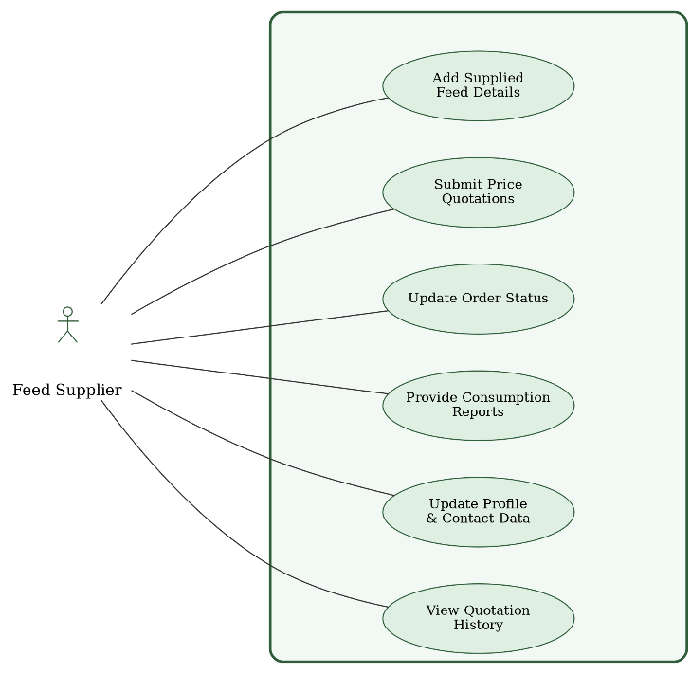
3.7.5 Use Case Diagram for Feed Supplier:

Textual Description of Feed Supplier Use Cases:
Requirement ID | RB-01
Description | Adding details of the food items supplied (quantity/quality)
Actors | Feed Supplier
Pre-conditions | - The supplier is registered in the system.  - The supplier has successfully logged in.
Post-conditions | - The supply data has been saved in the system.  - Data is available for management and monitoring.
Main Flow | 1. The supplier logs into the system.  2. Navigates to the "Food Supply" section.  3. Specifies the type of supplied material (corn, feed, supplements, etc.).  4. Enters the supplied quantity.  5. Rates the quality (high, medium, low or according to specific standards).  6. Adds the date and any additional notes.  7. Clicks "Save".  8. The system displays a message: "Supply added successfully."
Alternative Flow | - Supplier not registered or not logged in: Redirected to the login page.  - Incomplete data entry: A message appears: "Please enter all required fields."  - Save failure due to technical error: A message appears: "An error occurred while saving, please try again later."
35: Use Case Description of Adding details of the food items supplied (quantity/quality)

Requirement ID | RB-02
Description | Submitting direct quotations via the system
Actors | Feed Supplier
Pre-conditions | - The supplier is registered in the system.  - The supplier has successfully logged in.
Post-conditions | - The price quote has been saved successfully.  - The quote is now available to management for review or evaluation.
Main Flow | 1. The supplier logs into the system.  2. Navigates to the "Price Quotes" section.  3. Clicks "Add New Quote".  4. Selects the type of food material (e.g., feed, corn, supplements).  5. Specifies the quantity covered by the quote.  6. Enters the proposed price per unit.  7. Adds the quote date and validity period.  8. Can add notes or additional conditions.  9. Clicks "Submit".  10. The system displays a message: "Price quote submitted successfully."
Alternative Flow | - Supplier not logged in: Redirected to login first.  - Incomplete or incorrect entry: A message appears: "Please complete all required fields correctly."  - Save or connection failure: A message appears: "Unable to submit quote, please try again later."
36: Use Case Description of Submitting direct quotations via the system

Requirement ID | RB-03
Description | Update the status of previous orders (Delivered/Not Delivered)
Actors | Feed Supplier
Pre-conditions | - The supplier is registered in the system.  - The supplier has successfully logged in.
Post-conditions | - The order status has been updated successfully.  - The new status is available to management and for monitoring.
Main Flow | 1. The supplier logs into the system.  2. Navigates to the "Previous Orders" section.  3. Reviews the list of their orders.  4. Selects the order whose status is to be updated.  5. Selects the status (Delivered / Not Delivered).  6. Can enter additional notes, such as the reason for delay.  7. Clicks "Update".  8. The system displays a confirmation message: "Order status updated successfully."
Alternative Flow | - Supplier not logged in: A warning appears and login is requested.  - No orders linked to the supplier: The system displays a message: "No orders to display."  - Update failure due to technical error: A message appears: "Unable to update status, please try again later."
37: Use Case Description of Update the status of previous orders (Delivered/Not Delivered)

Requirement ID | RB-05
Description | Provide reports on food consumption to determine future quantities required
Actors | Feed Supplier
Pre-conditions | - The supplier is registered in the system.  - The supplier has successfully logged in.
Post-conditions | - The report has been sent to management.  - It is now available in the reports and analytics database.
Main Flow | 1. The supplier logs into the system.  2. Navigates to the "Consumption Reports" section.  3. Selects the time period (e.g., month, quarter).  4. Enters consumption details (material type, quantity consumed, quality notes).  5. Clicks "Submit Report".  6. The system displays a message: "Report submitted successfully."
Alternative Flow | - Supplier not logged in: A warning appears: "Please log in first."  - Incomplete detail entry: A message appears: "Please complete all required fields. "Technical failure during submission: A message appears: "An error occurred during submission, please try again later."
Requirement ID | RB-04
Description | Edit and delete quotations
Actors | Feed Supplier
Preconditions | - Food supplier is logged in.  - Pricing offer exists in the system
Postconditions | Offer is updated or deleted from the system.
Main Flow | 1. Food supplier clicks "My Offers".  2. System shows list of pricing offers.  3. Supplier selects an offer.  4. Supplier clicks "Edit" or "Delete".  5. If Edit: Supplier modifies price or details and clicks "Save". System shows "Offer updated".  6. If Delete: System shows "Offer deleted".
Alternative Flow | If offer does not exist: System shows "No offers found".
38: Use Case Description of Edit and delete quotations

39: Use Case Description of Provide reports on food consumption to determine future quantities required

Requirement ID | RB-06
Description | Editing, deleting and printing food consumption reports
Actors | Feed Supplier
Preconditions | 1- Food supplier is logged in.  2- Food consuming reports exist
Postconditions | 1- Reports are updated, deleted, or printed as requested.
Main Flow | 1. Food supplier clicks "Food Consuming Report  2. System shows list of reports.  3. Supplier selects a report.  4. Supplier chooses action: Edit, Delete, or Print. 5. If Edit: Supplier modifies data and clicks "Save". System shows "Report updated".  6. If Delete: System shows "Report deleted".  7. If Print: System sends report to printer.
Alternative Flow | If no reports exist: System shows "No reports found".
40: Use Case Description of Editing, deleting and printing food consumption reports
RB-07 | Requirement ID
Updating the supplier’s profile and contact information | Description:
Feed Supplier | Actors:
1. The Supplier must be successfully logged into their account in the system.  2. The system must be connected to the database to perform update operations. | Prerequisites:
1. The Supplier's contact information is immediately modified in the database.  2. The Supplier's interface updates to reflect the new data.  3. The updated data (such as the new phone number) is displayed to the Manager  to ensure seamless communication. | Subsequent  Conditions:
1. The Supplier logs into their account and selects the "Profile" option from the  menu.  2. The system opens a form containing the current company data (Name, Phone,  Address).  3. The Supplier modifies the data or updates contact numbers in the designated  fields.  4. The Supplier clicks on the "Update Account" button.  5. The system validates the inputs and checks the data format (such as phone  number validity).  6. If the data is valid:  * The new modifications are saved in the database.  * A confirmation message appears stating that the profile has been successfully updated. | Main Flow:

41: Use Case Description of Updating the supplier’s profile and contact information

RB-08 | Requirement ID
Viewing the history of previous quotations for reference | Description:
Feed Supplier | Actors:
1. The Supplier must be successfully logged into their account.  2. Past, canceled, or accepted price quotes previously submitted by this Supplier  must exist. | Prerequisites:
1. An organized timeline containing all historical prices of the Supplier is displayed.  2. Data is displayed in a "Read-Only" format to protect previous contracts and  agreements from tampering. | Subsequent  Conditions:
1. The Supplier navigates to the "Price Quotations" screen in their account.  2. The Supplier clicks on the "Previous Prices Archive" tab.  3. The system automatically retrieves all price records associated only with this  Supplier's ID.  4. The records are sorted and arranged chronologically from newest to oldest.  5. The system displays the records in an organized table showing (item type,  submitted price, date, and quote status). | Main Flow:

42: Use Case Description of Viewing the history of previous quotations for reference

3.7.6 Use Case Diagram for Fuel Supplier:
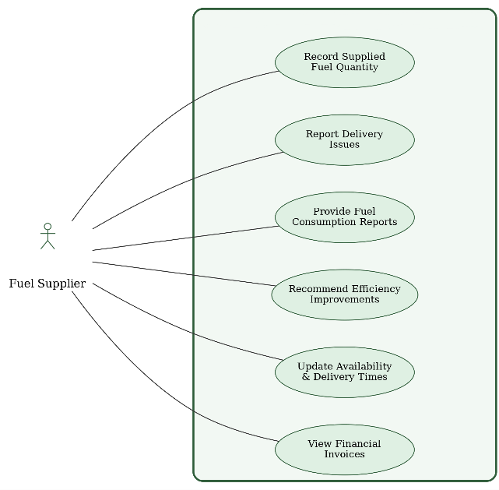

Textual Description of Fuel Supplier Use Cases:
Code | FS-01
Description | Recording the amount of fuel supplied in each operation
Actors | Fuel Supplier
Pre-conditions | - The supplier is registered in the system.  - The supplier has successfully logged in.
Post-conditions | - The supplied fuel quantity has been recorded successfully.  - Data is available for management and monitoring.
Main Flow | 1. The supplier logs into the system.  2. Navigates to the "Fuel Supply" section.  3. Clicks "Add Supply Operation".  4. Enters the fuel type (solar, diesel, etc.).  5. Enters the supplied quantity (in liters or tons).  6. Specifies the supply date and receiving farm.  7. Adds notes if applicable.  8. Clicks "Save".  9. The system displays a message: "Supply recorded successfully."
Alternative Flow | - Supplier not logged in: A warning appears: "You must log in first."  - Quantity or required data not entered: A message appears: "Please fill in all mandatory fields."  - Save failure due to technical issue: A message appears: "An error occurred while saving, please try again later."

43: Use Case Description of Recording the amount of fuel supplied in each operation

Code | FS-02
Description | Report any delivery problem
Actors | Fuel Supplier
Pre-conditions | - The supplier is registered in the system.  - Logged in successfully.  - A previously registered delivery operation exists.
Post-conditions | - The report has been recorded in the system.  - It is now visible to facility management for review and action.
Main Flow | 1. The supplier logs into the system.  2. Navigates to the "Reports / Deliveries" section.  3. Selects the delivery operation with the issue.  4. Clicks "Report a Problem".  5. Specifies the type of problem (e.g., delay, quantity shortage, vehicle issue, etc.).  6. Enters a detailed description of the problem.  7. Attaches photos/documents if available.  8. Clicks "Submit Report".  9. The system displays a message: "Report submitted successfully."
Alternative Flow | - Not logged in: The supplier is redirected to the login page.  - Required fields not filled: A message appears: "Please fill in all required fields."  - Technical failure during submission: A message appears: "An error occurred during submission, please try again later."
44: Use Case Description of Report any delivery problem

Code | FS-03
Description | Submitting periodic reports on fuel consumption
Actors | Fuel Supplier
Pre-conditions | - The supplier is registered in the system.  - Logged in successfully.  - Previous supply operations linked to the supplier exist.
Post-conditions | - The report has been saved in the system.  - It is now available to management for analysis and planning purposes.
Main Flow | 1. The supplier logs into the system.  2. Navigates to the "Fuel Consumption Reports" section.  3. Clicks "Add New Report".  4. Specifies the time period (weekly, monthly, quarterly).  5. Enters fuel quantities consumed by period or by farm.  6. Adds notes (e.g., observations on efficiency or future needs).  7. Clicks "Submit Report".  8. The system displays a message: "Report submitted successfully."
Alternative Flow | - Supplier not logged in: Login is required.  - Not all required data entered: A message appears: "Please complete all required fields."  - Report submission failure: A message appears: "An error occurred during submission, please try again later."
45: Use Case Description of Submitting periodic reports on fuel consumption

Code | FS-04
Description | Providing recommendations to improve fuel efficiency and reduce costs
Actors | Fuel Supplier
Pre-conditions | - The supplier is registered in the system.  - Logged in successfully.  - Previous supply operations linked to the supplier exist.
Post-conditions | - The recommendations have been saved in the system.  - They are now visible to management for consideration and action.
Main Flow | 1. The supplier logs into the system.  2. Navigates to the "Recommendations" section.  3. Clicks "Add New Recommendation".  4. Writes the recommendation text (e.g., using specific fuel types, improving thermal insulation, energy-saving technologies, etc.).  5. Attaches supporting files if available (photos, reports, PDF documents).  6. Clicks "Submit Recommendation".  7. The system displays a message: "Recommendation submitted successfully."
Alternative Flow | - Not logged in: A warning appears: "You must log in to submit a recommendation."  - Recommendation incomplete or fields empty: A warning appears: "Please enter the recommendation text at least."  - Submission failure due to system malfunction: A message appears: "Unable to submit recommendation, please try again later."
46: Use Case Description of Providing recommendations to improve fuel efficiency and reduce costs

Requirement ID | FS-05
Requirement Name | Editing, deleting and printing fuel status reports
Actors | Fuel Supplier
Preconditions | 1- Fuel supplier is logged in.  2- Fuel consumption reports exist.
Postconditions | Reports are updated, deleted, or printed as requested.
Main Flow | 1. Fuel supplier clicks "Fuel Consumption Reports".  2. System shows list of reports.  3. Supplier selects a report.  4. Supplier chooses action: Edit, Delete, or Print. 5. If Edit: Supplier modifies data and clicks "Save". System shows "Report updated".  6. If Delete: System asks "Are you sure?" Supplier clicks "Yes". System shows "Report deleted".  7. If Print: System sends report to printer.
Alternative Flow | If no reports exist: System shows "No reports found".

47: Use Case Description of Editing, deleting and printing fuel status reports

FS-06 | Requirement ID
Updating availability schedules and available delivery times | Description:
Fuel Supplier | Actors:
1. The Supplier must be successfully logged into their account.  2. The system must be connected to the database to save changes. | Prerequisites:
1. Available working days and hours for shipping deliveries are saved in the  Supplier's profile.  2. These specific times appear only to the Facility Manager when purchasing fuel to ensure successful coordination of delivery operations. | Subsequent  Conditions:
1. The Fuel Supplier enters the "Supply Settings and Working Hours" page.  2. The system displays an interface containing the days of the week and working  hours with selection switches (Toggles).  3. The Supplier specifies the days and times they are ready to ship and deliver fuel to the farm.  4. The Supplier clicks on the "Save Schedule" button.  5. The system processes the request and updates the availability fields of the  Supplier in the database.  6. A message appears confirming to the Supplier that the delivery times have been successfully saved and activated. | Main Flow:

48: Use Case Description of Editing, deleting and printing fuel status reports

FS-07 | Requirement ID
Displaying financial invoices received and related to delivered shipments | Description:
Fuel Supplier | Actors:
1. The Supplier must be successfully logged into their account.  2. Fuel shipments must have been delivered and financially confirmed by the  facility management. | Prerequisites:
1. An integrated table of all completed financial invoices is displayed for accounting documentation.  2. Providing the option to locally print and export the invoice for the Supplier's  external accounting purposes. | Subsequent  Conditions:
1. The Fuel Supplier enters the "Invoices and Finance" section in their personal  account.  2. The system sends an automated request to retrieve invoices associated with this vendor.  3. The server searches for completed fuel supply orders that carry the status  (Delivered and Paid).  4. The data is transferred and displayed in a detailed financial table in front of the  Supplier.  5. The Supplier reviews the invoices, which include (order number, quantity of fuel supplied, total price, and payment date), with the ability to print them. | Main Flow:

49: Use Case Description of Displaying financial invoices received and related to delivered shipments

Sequence Diagram:3.8

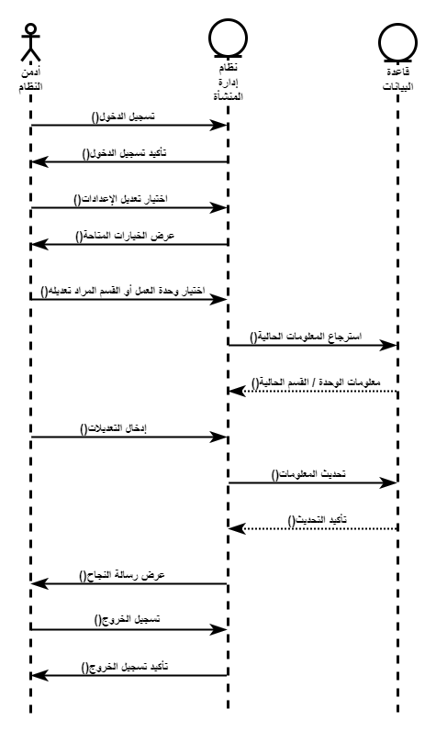

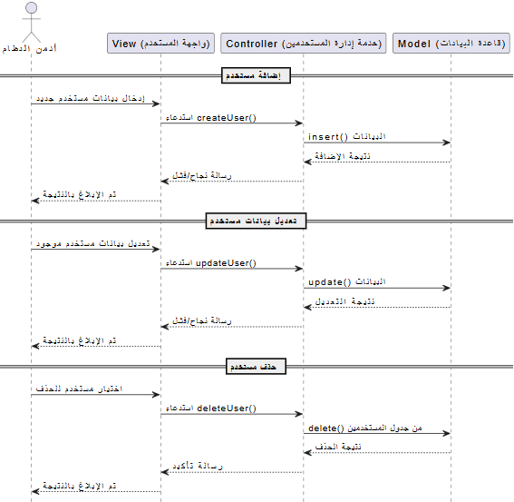
3.8.1 Manage user data (add/modify/delete):
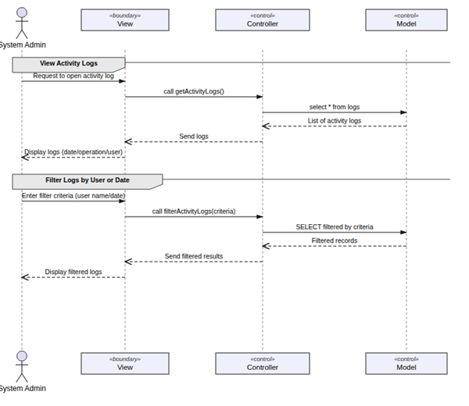

3.8.2 View system settings:

3.8.3 Monitor activity logs to keep track of system usage:

3.8.4 Change user account status (Active/Freeze):
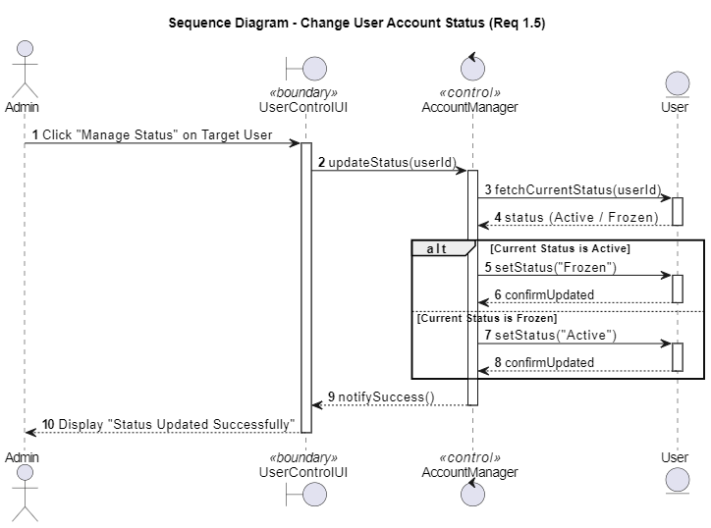

3.8.5 View general system statistics:

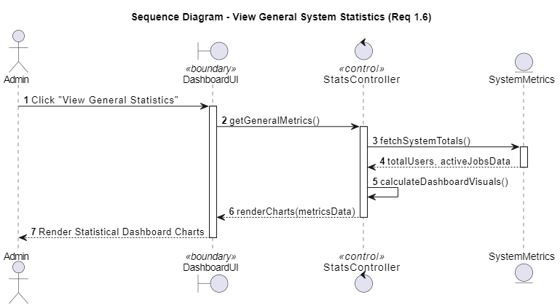

.6 Create production and profit reports based on available data: 3.8
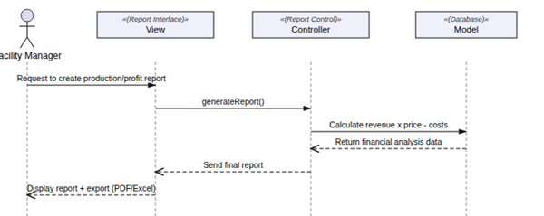

3.8.7 Plan and schedule Resources(food/fuel):

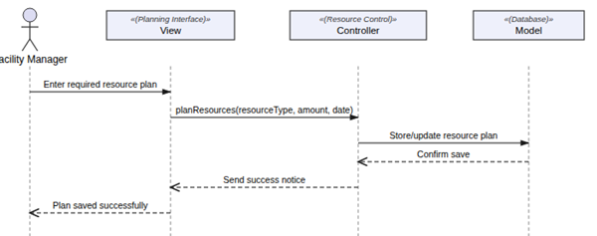

3.8.8 Request feed from the food supplier:

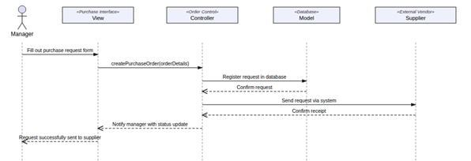
3.8.9 Send new purchase orders to suppliers:

3.8.10 Request vaccines and medicines from the veterinarian:

3.8.11 Track and analyze performance data to identify improvement opportunities and make strategic decisions:
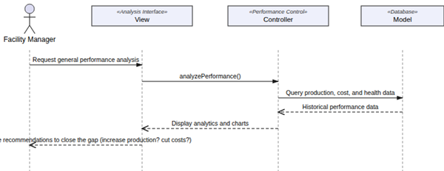

3.8.12 Request equipment from the equipment supplier:

3.8.13 Send a recommendation to improve activity logs:

3.8.14 Send a recommendation to improve production (feed quantity – number of eggs produced):

3.8.15 Send a recommendation to improve facility resource utilization:

3.8.16 Assign a new worker:

3.8.17 Set minimum inventory to alert the system when feed or fuel is low:
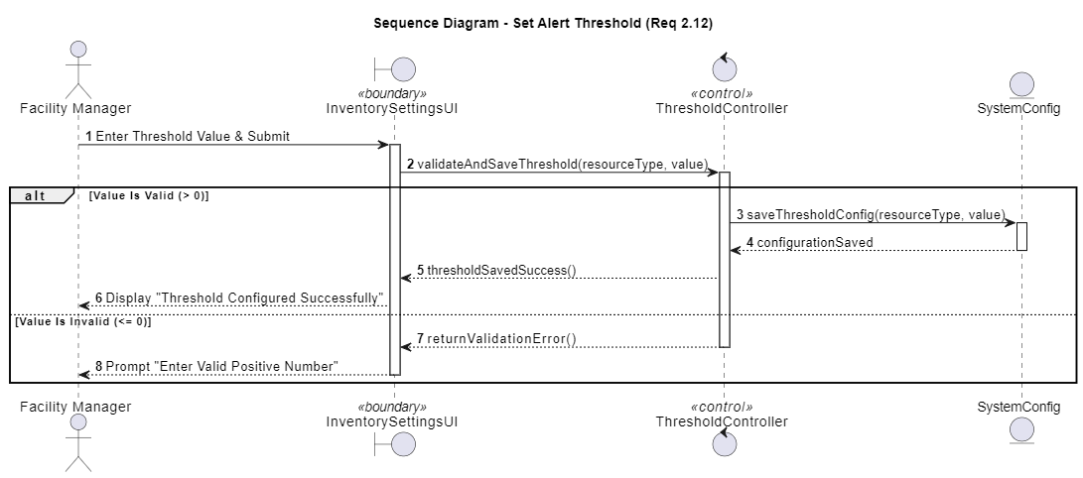

3.8.18 Review the annual archive of previous facility data:
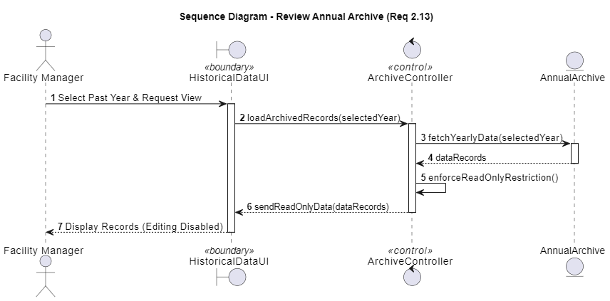

3.8.19 Recording veterinary examinations for individual and group cases

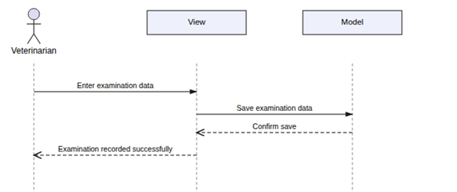

3.8.20 Providing specialized feeding plans to ensure the health and proper growth of poultry:

3.8.21 Displaying and printing the reports log:

3.8.22 Follow-up of prevention and treatment plans:

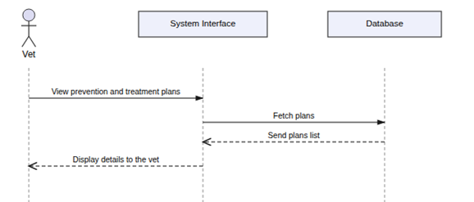

3.8.23 Providing recommendations to improve the health environment within the facility:

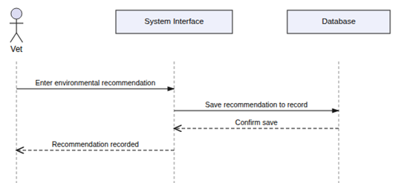

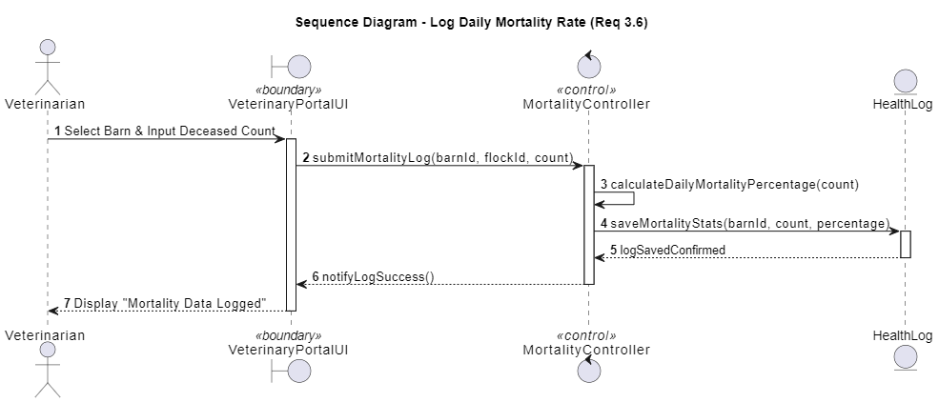
3.8.24 Recording the daily mortality rate of birds:

3.8.25 Printing and exporting proposed “prescriptions” to send to the manager or suppliers:
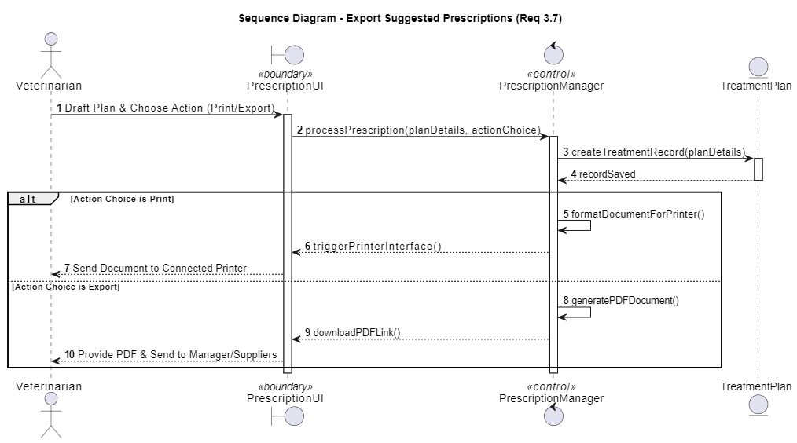

3.8.26 Recording daily poultry feeding data:
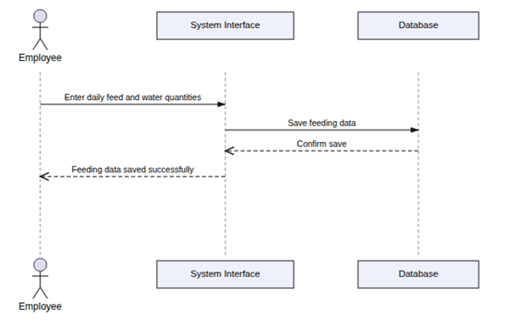

3.8.27 Viewing and printing sorting and packing operations:

3.8.28 Viewing and printing reports from the suppliers and the veterinarian:

3.8.29 Edit reports received from the suppliers and the veterinarian:

3.8.30 Report abnormalities using simple forms:
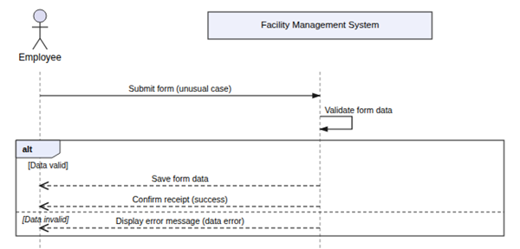

3.8.31 Updating the facility's cleanliness status:
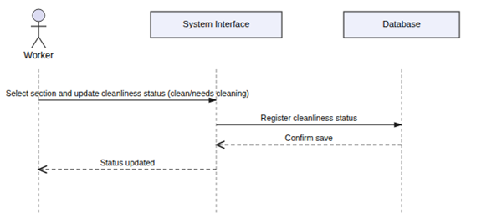

3.8.32 Assisting with sorting and packing operations when preparing poultry for sale:
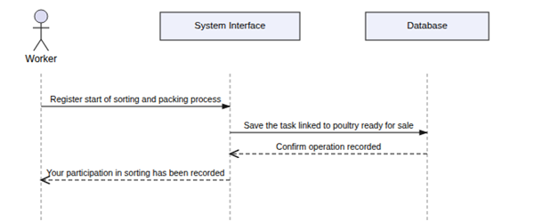

3.8.33 Record daily attendance and departure times:
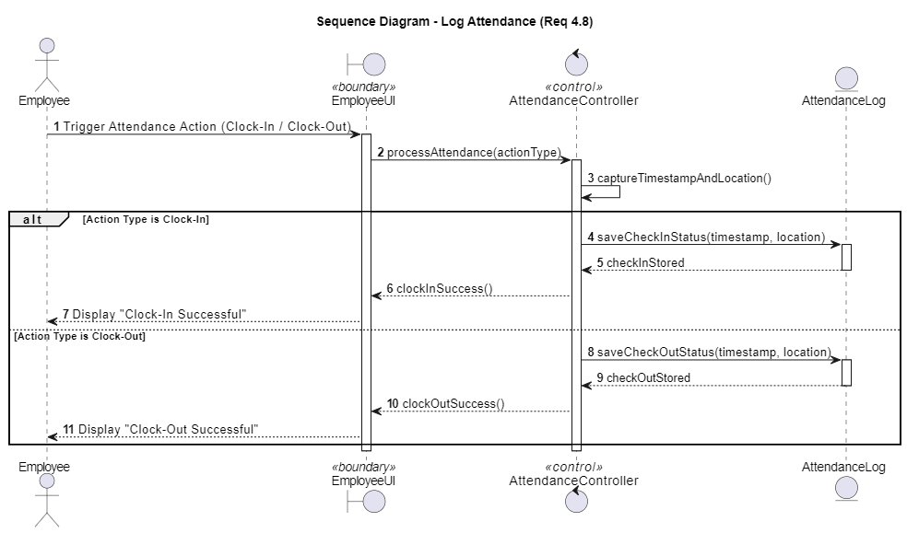

3.8.34 Viewing the daily tasks schedule assigned by management:
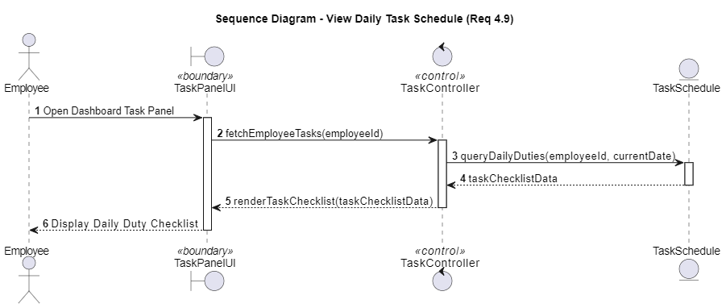

3.8.35 Submitting direct quotations via the system:
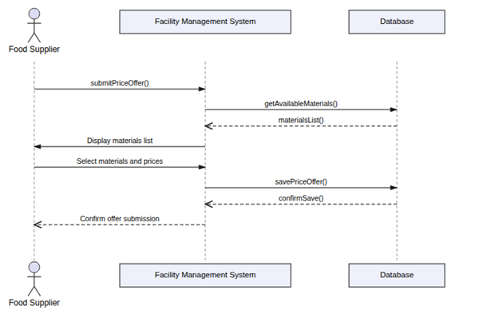

3.8.36 Edit and delete quotations:

3.8.37 Provide reports on food consumption to determine future quantities required:

3.8.38 Editing, deleting and printing food consumption reports:

3.8.39 Update the status of previous orders (Delivered/Not Delivered):
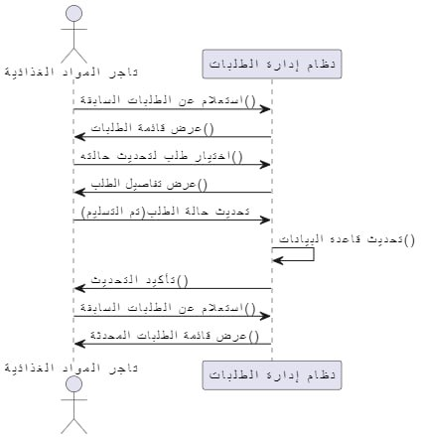

3.8.40 Adding details of the food items supplied:

3.8.41 Updating the supplier’s profile and contact information:

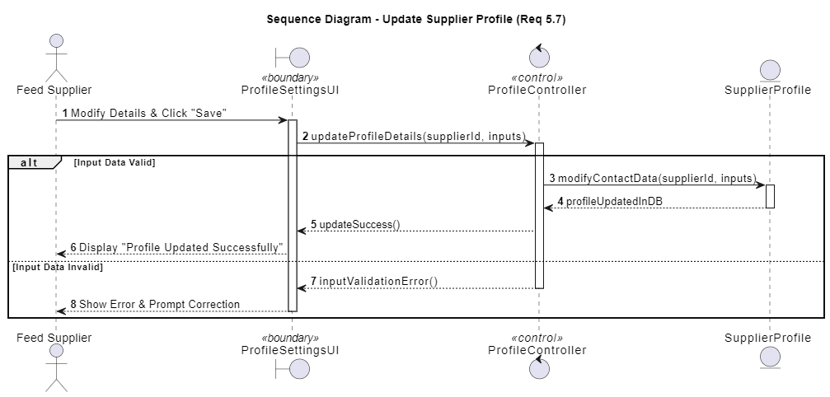

3.8.42 Viewing the history of previous quotations for reference:
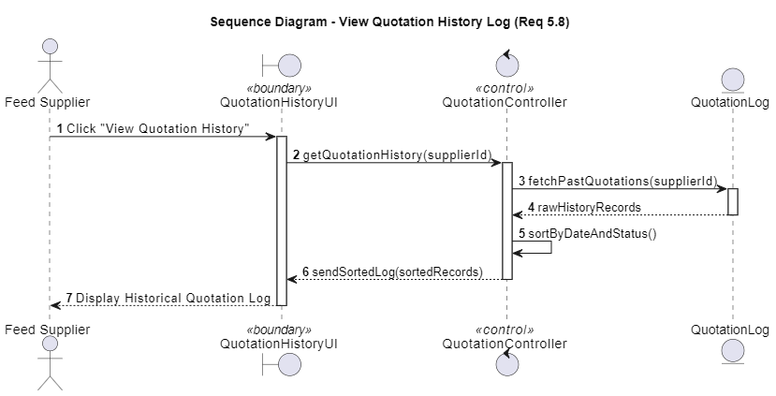

3.8.43 Recording the amount of fuel supplied in each operation:
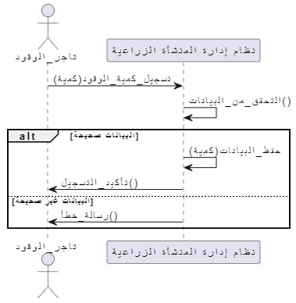

3.8.44 Report any delivery problem:

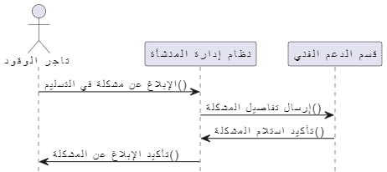

3.8.45 Submitting periodic reports on fuel consumption:

3.8.46 Providing recommendations to improve fuel efficiency and reduce costs:
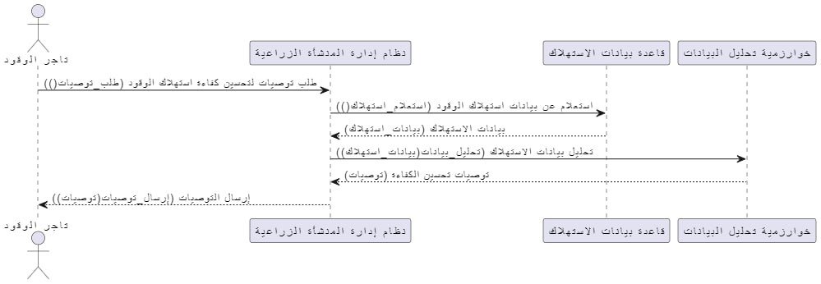

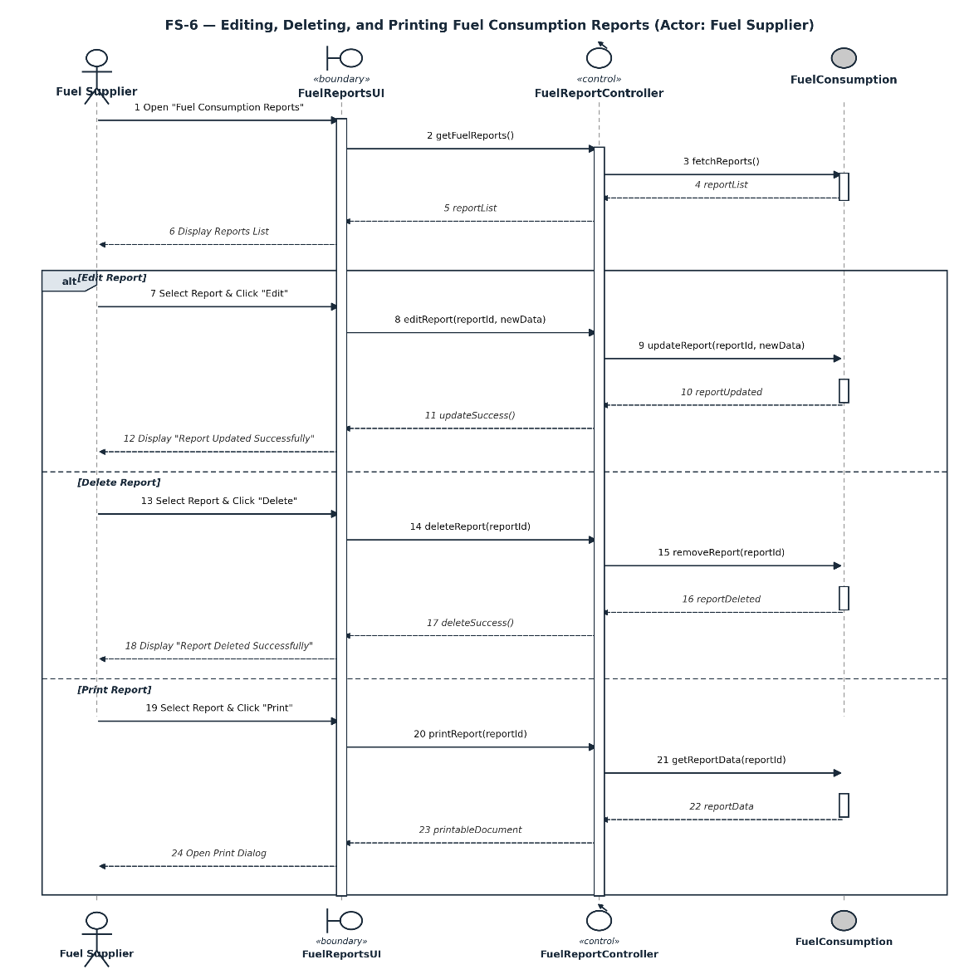
3.8.47 Editing, deleting and printing fuel status reports:

3.8.48 Updating availability dates and delivery times available:
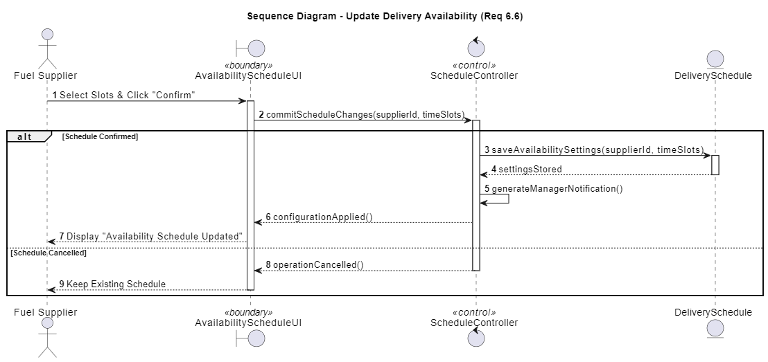

3.8.49 Displaying financial invoices received and related to delivered shipments:
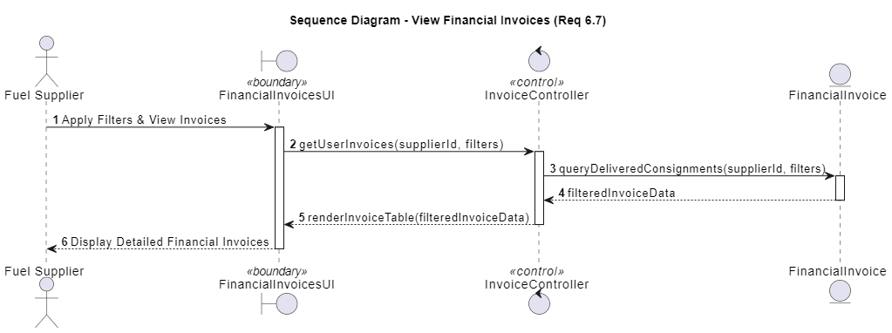

RTM:
Req. ID | Requirement Description | Actor / Role | Priority | Code File Path | Test Status | Implementation Status
Uc-01 | Manage user data (add/modify/delete) | System Admin | High | ..\poultry-finalversion\client\src\components\UserTable.jsx  ..\poultry-finalversion\client\src\pages\admin\Employee.jsx | Passed | Implemented & Verified
Uc-02 | Modify system settings (work units/departments) | System Admin | Medium | ..\poultry-finalversion\client\src\components\SystemManegement.jsx  ..\poultry-finalversion\client\src\pages\admin\SystemPage.jsx | Passed | Implemented & Verified
Uc-03 | Monitor activity logs to keep track of system usage | System Admin | High | ..\poultry-finalversion\client\src\components\ActivityRecords.jsx  ..\poultry-finalversion\client\src\pages\ActivityPage.jsx | Passed | Implemented & Verified
M-01 | Create production and profit reports based on available data | Facility Manager | High | ..\poultry-finalversion\server\controllers\reportsController.js  ..\poultry-finalversion\client\src\components\ProductionReborts.jsx  ..\poultry-finalversion\client\src\pages\ProductionPage.jsx | Passed | Implemented & Verified
M-02 | Generate production and profit reports based on available data | Facility Manager | High | ..\poultry-finalversion\server\controllers\reportsController.js  ..\poultry-finalversion\client\src\pages\HomePage.jsx | Passed | Implemented & Verified
M-03 | Plan and schedule resources (food/fuel) | Facility Manager | High | ..\poultry-finalversion\client\src\components\ResourcePlanning.jsx  ..\poultry-finalversion\client\src\pages\ResourcePage.jsx | Passed | Implemented & Verified
M-04 | Send new purchase orders to suppliers | Facility Manager | Medium | ..\poultry-finalversion\server\controllers\foodOrderController.js  ..\poultry-finalversion\server\controllers\fuelOrderController.js  ..\poultry-finalversion\server\routes\foodOrderRoutes.js  ..\poultry-finalversion\server\routes\fuelOrderRoutes.js | Passed | Implemented & Verified
M-05 | Track and analyze performance data for improvement opportunities | Facility Manager | Medium | ..\poultry-finalversion\client\src\components\TasksOverview.jsx  ..\poultry-finalversion\client\src\pages\manager\ProductivityReportsPage.jsx | Passed | Implemented & Verified
M-06 | Request feed from the food supplier | Facility Manager | High | ..\poultry-finalversion\server\controllers\foodOrderController.js  ..\poultry-finalversion\client\src\components\FoodRequestForm.jsx  ..\poultry-finalversion\client\src\pages\FoodPage.jsx | Passed | Implemented & Verified
M-07 | Request vaccines and medicines from the veterinarian | Facility Manager | High | ..\poultry-finalversion\server\controllers\medicalRequestController.js  ..\poultry-finalversion\client\src\components\MedicalRequest.jsx  ..\poultry-finalversion\client\src\pages\MedicalRequestPage.jsx | Passed | Implemented & Verified
M-08 | Request equipment from the equipment supplier | Facility Manager | Medium | ..\poultry-finalversion\server\controllers\fuelOrderController.js  ..\poultry-finalversion\client\src\components\HeatingFuelRequestForm.jsx  ..\poultry-finalversion\client\src\pages\FuelPage.jsx | Passed | Implemented & Verified
M-09 | Assign a new worker | Facility Manager | Medium | ..\poultry-finalversion\server\controllers\authController.js  ..\poultry-finalversion\client\src\components\EmployeeForm.jsx | Passed | Implemented & Verified
M-10 | Send a recommendation to improve activity logs | Facility Manager | Low | ..\poultry-finalversion\server\controllers\managerRecommendationController.js  ..\poultry-finalversion\client\src\components\ManagerRecommendations.jsx  ..\poultry-finalversion\client\src\pages\manager\ProductivityReportsPage.jsx | Passed | Implemented & Verified
M-11 | Set minimum inventory alert threshold for feed/fuel | Facility Manager | Medium | ..\poultry-finalversion\server\controllers\foodOrderController.js  ..\poultry-finalversion\server\controllers\fuelOrderController.js  ..\poultry-finalversion\server\models\FoodOrder.js  ..\poultry-finalversion\server\models\FuelOrder.js | Passed | Implemented & Verified
M-12 | Analyze performance data to identify opportunities and make strategic decisions | Facility Manager | High | ..\poultry-finalversion\server\controllers\reportsController.js  ..\poultry-finalversion\client\src\components\ManagerRecommendations.jsx | Passed | Implemented & Verified
Vet-01 | Record veterinary examinations for individual and group cases | Veterinarian | High | ..\poultry-finalversion\server\controllers\medicalExaminationController.js  ..\poultry-finalversion\server\middleware\medicalExaminationMiddleware.js  ..\poultry-finalversion\client\src\components\MedicalForm.jsx  ..\poultry-finalversion\client\src\pages\vet\Vet.jsx | Passed | Implemented & Verified
Vet-02 | Monitor prevention and treatment plans | Veterinarian | High | ..\poultry-finalversion\server\controllers\preventionPlanController.js  ..\poultry-finalversion\server\middleware\preventionPlanMiddleware.js  ..\poultry-finalversion\client\src\components\HealthSafety.jsx  ..\poultry-finalversion\client\src\pages\vet\PreventionPage.jsx | Passed | Implemented & Verified
Vet-03 | Provide recommendations to improve the health environment within the facility | Veterinarian | Medium | ..\poultry-finalversion\server\controllers\preventionPlanController.js  ..\poultry-finalversion\client\src\components\HealthSafety.jsx | Passed | Implemented & Verified
Vet-04 | Provide specialized dietary plans for poultry health and growth | Veterinarian | Medium | ..\poultry-finalversion\server\controllers\feedingPlanController.js  ..\poultry-finalversion\client\src\components\FeedingPlans.jsx  ..\poultry-finalversion\client\src\pages\vet\FeedingPlansPage.jsx | Passed | Implemented & Verified
Vet-05 | Display and print reports records | Veterinarian | Low | ..\poultry-finalversion\client\src\components\MedicalReports.jsx  ..\poultry-finalversion\client\src\pages\MedicalReportsPage.jsx | Passed | Implemented & Verified
Emp-01 | Record daily feeding data for poultry | Employee | High | ..\poultry-finalversion\server\controllers\foodConsumptionController.js  ..\poultry-finalversion\client\src\components\FoodConsumptionForm.jsx  ..\poultry-finalversion\client\src\pages\FoodCunsumptionPage.jsx | Passed | Implemented & Verified
Emp-02 | Report abnormalities using simple forms | Employee | Medium | ..\poultry-finalversion\server\controllers\sanitationReportController.js  ..\poultry-finalversion\server\middleware\sanitationMiddleware.js  ..\poultry-finalversion\client\src\components\CleaningService.jsx | Passed | Implemented & Verified
Emp-03 | Update the facility's cleanliness status | Employee | Medium | ..\poultry-finalversion\server\controllers\sanitationReportController.js  ..\poultry-finalversion\client\src\components\CleaningService.jsx  ..\poultry-finalversion\client\src\pages\employee\CleaningPage.jsx | Passed | Implemented & Verified
Emp-04 | Assist with sorting and packing operations | Employee | Medium | ..\poultry-finalversion\server\controllers\packingOperationController.js  ..\poultry-finalversion\client\src\components\PackingOperationForm.jsx  ..\poultry-finalversion\client\src\pages\PackingOperationsPage.jsx | Passed | Implemented & Verified
Emp-05 | View and print sorting and packing operations | Employee | Low | ..\poultry-finalversion\client\src\components\PackingReports.jsx  ..\poultry-finalversion\client\src\pages\PackingReportsPage.jsx | Passed | Implemented & Verified
Emp-06 | View and print reports from suppliers and veterinarian | Employee | Low | ..\poultry-finalversion\client\src\components\MedicalReports.jsx  ..\poultry-finalversion\client\src\components\FoodConsumptionReports.jsx  ..\poultry-finalversion\client\src\components\FuelConsumptionReports.jsx | Passed | Implemented & Verified
Emp-07 | Edit reports received from suppliers and veterinarian | Employee | Medium | ..\poultry-finalversion\client\src\components\HealthSafetyReports.jsx  ..\poultry-finalversion\client\src\components\SanitationReports.jsx | Passed | Implemented & Verified
Emp-08 | Record daily attendance and departure times | Employee | Medium | ..\poultry-finalversion\server\controllers\attendanceController.js  ..\poultry-finalversion\server\routes\attendanceRoutes.js  ..\poultry-finalversion\client\src\components\AttendanceButtons.jsx  ..\poultry-finalversion\client\src\components\AttendanceHistory.jsx  ..\poultry-finalversion\client\src\api\attendance.jsx | Passed | Implemented & Verified
RB-01 | Add details of the food items supplied (quantity/quality) | Feed Supplier | High | ..\poultry-finalversion\server\controllers\foodConsumptionController.js  ..\poultry-finalversion\client\src\components\FoodConsumptionForm.jsx | Passed | Implemented & Verified
RB-02 | Submit direct quotations via the system | Feed Supplier | Medium | ..\poultry-finalversion\server\controllers\pricingController.js  ..\poultry-finalversion\client\src\components\Pricing.jsx  ..\poultry-finalversion\client\src\pages\PricingPage.jsx | Passed | Implemented & Verified
RB-03 | Update the status of previous orders (Delivered/Not Delivered) | Feed Supplier | High | ..\poultry-finalversion\server\controllers\foodOrderController.js  ..\poultry-finalversion\server\routes\foodOrderRoutes.js | Passed | Implemented & Verified
RB-04 | Edit and delete quotations | Feed Supplier | Low | ..\poultry-finalversion\server\controllers\pricingController.js  ..\poultry-finalversion\client\src\components\Pricing.jsx | Passed | Implemented & Verified
RB-05 | Provide reports on food consumption for future planning | Feed Supplier | Medium | ..\poultry-finalversion\server\controllers\foodConsumptionController.js  ..\poultry-finalversion\client\src\components\FoodConsumptionReports.jsx  ..\poultry-finalversion\client\src\pages\food_supplier\FoodConsumptionReportsPage.jsx | Passed | Implemented & Verified
RB-06 | Update supplier profile and contact information | Feed Supplier | Low | ..\poultry-finalversion\client\src\pages\food_supplier\FoodSupplierProfilePage.jsx | Passed | Implemented & Verified
RB-07 | Edit, delete, and print food consumption reports | Feed Supplier | Medium | ..\poultry-finalversion\client\src\components\FoodConsumptionReports.jsx  ..\poultry-finalversion\client\src\pages\food_supplier\FoodConsumptionReportsPage.jsx | Passed | Implemented & Verified
FS-01 | Report any delivery problem | Fuel Supplier | Medium | ..\poultry-finalversion\server\controllers\foodOrderController.js  ..\poultry-finalversion\server\middleware\fuelOrderMiddleware.js | Passed | Implemented & Verified
FS-02 | Record the quantity of fuel supplied in each operation | Fuel Supplier | High | ..\poultry-finalversion\server\controllers\fuelConsumptionController.js  ..\poultry-finalversion\client\src\components\FuelConsumptionForm.jsx  ..\poultry-finalversion\client\src\pages\fuel_supplier\FuelConsumptionPage.jsx | Passed | Implemented & Verified
FS-03 | Submit periodic reports on fuel consumption | Fuel Supplier | Medium | ..\poultry-finalversion\server\controllers\fuelConsumptionController.js  ..\poultry-finalversion\client\src\components\FuelConsumptionReports.jsx  ..\poultry-finalversion\client\src\pages\fuel_supplier\FuelConsumptionReportsPage.jsx | Passed | Implemented & Verified
FS-04 | Provide reports about fuel consumption | Fuel Supplier | Medium | ..\poultry-finalversion\server\controllers\fuelConsumptionController.js  ..\poultry-finalversion\client\src\pages\FuelReportsPage.jsx | Passed | Implemented & Verified
FS-05 | Provide recommendations to improve fuel efficiency and reduce costs | Fuel Supplier | Low | ..\poultry-finalversion\server\controllers\fuelConsumptionController.js  ..\poultry-finalversion\client\src\components\FuelConsumptionForm.jsx | Passed | Implemented & Verified
FS-06 | Edit, delete, and print fuel consumption report | Fuel Supplier | Low | ..\poultry-finalversion\client\src\components\FuelConsumptionReports.jsx  ..\poultry-finalversion\client\src\pages\fuel_supplier\FuelConsumptionReportsPage.jsx | Passed | Implemented & Verified

Chapter Four: Design Study

4.1 Class Diagram:
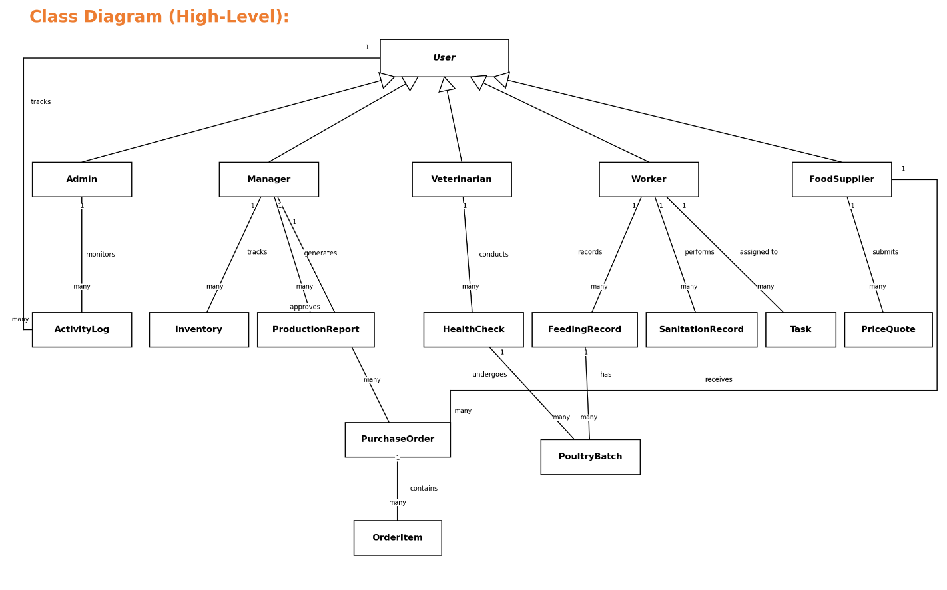

4.2 System Architecture:
System architecture refers to the overall structure and organization of components in a system. Aim to achieve goals effectively and systematically, taking into account compatibility, scalability, security, maintenance, and performance. In a poultry farming management system, it can include components such as the system frontend, database, content management system, and evaluation and analysis mechanisms.
MVC architecture is an architectural style that divides applications into three main components: Model, View, and Controller, this division aims to organize the application and facilitate its development and maintenance.

4.2.1 The architecture used:
In your project, the combination of MVC and client-server architectures creates a clean separation of concerns across the network. The client handles the View and Controller layers—responsible for user interaction and interface logic—while the server hosts the Model layer, managing data and business rules. This setup allows the client to send requests (e.g., form submissions or button clicks) to the server via an API, and the server responds with processed data, which the Controller then passes to the View for display. This approach enhances scalability, security (by keeping core logic on the server), and maintainability, as each component can evolve independently without disrupting the others.

4.2.1.1 Client-Server architecture:

4.2.1.2 MVC architecture:

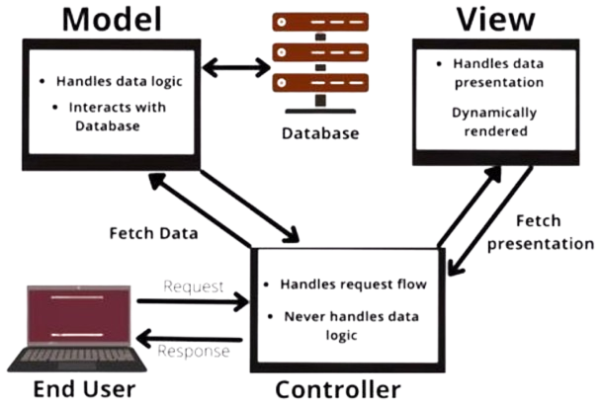

4.3 Components Diagram:
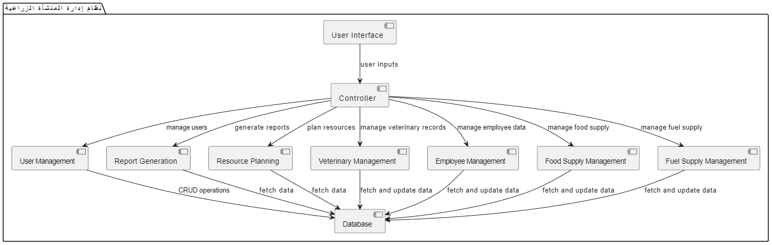

4.4 ERD Diagram:
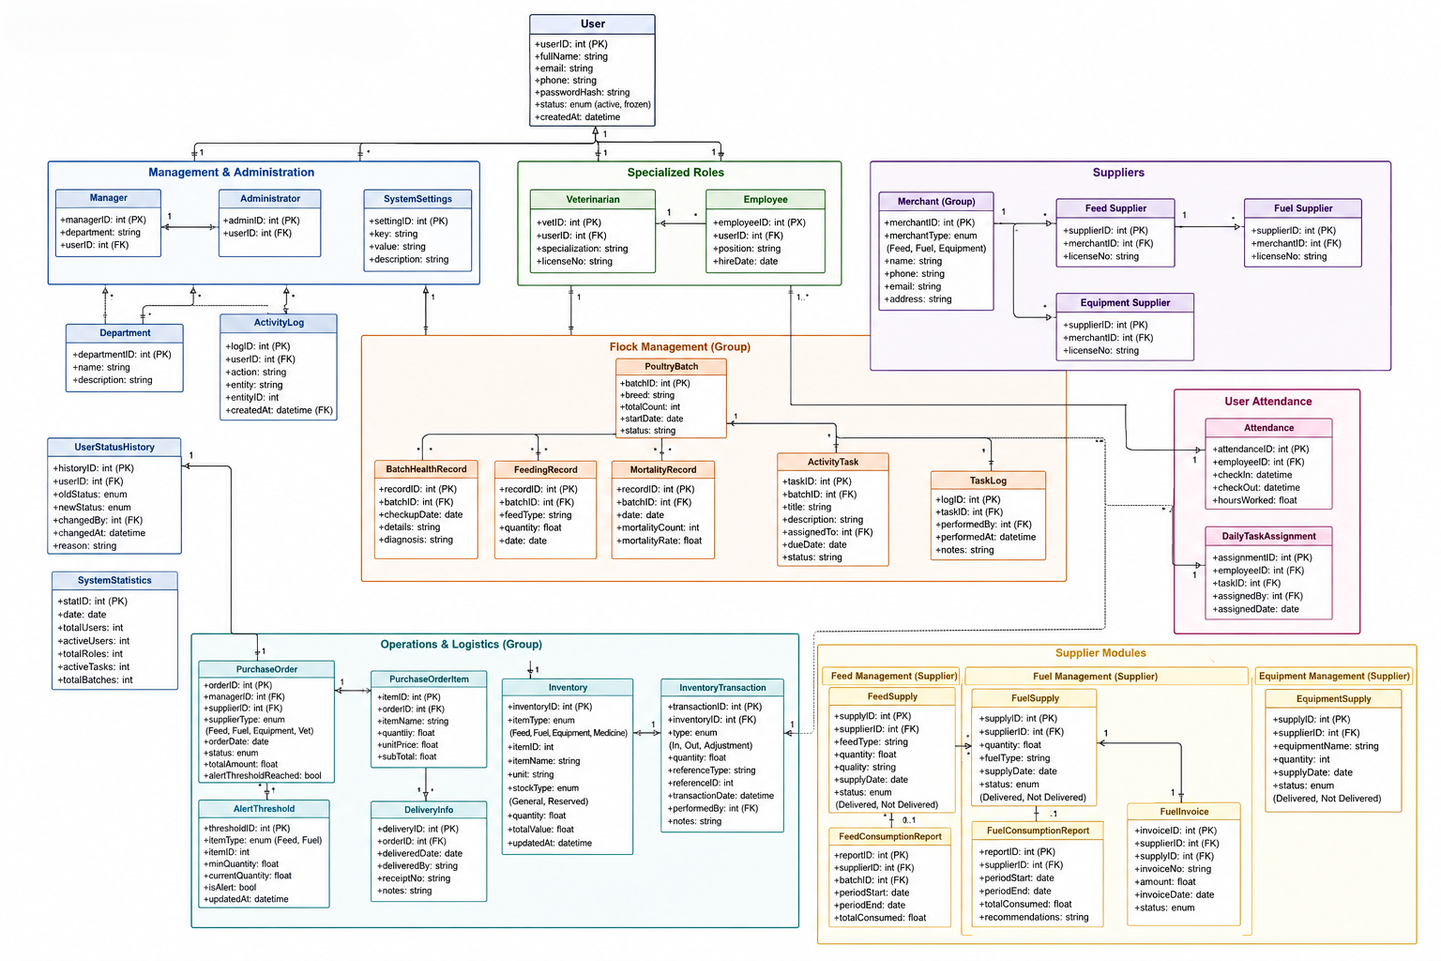

Chapter Five: implementation

5.1 Tools Used:

5.1.1 draw.io: It is a free and open-source diagramming software across the platform. Its interface can be used to create diagrams such as flowcharts, wireframes, UML diagrams, org charts, and grid diagrams.

5.1.2 VS Code: is a script editor from Microsoft. The editor is open-source and works on Windows, macOS, and Linux. The editor is based on the Electron environment, and was launched by Microsoft in April 2015.

5.1.3 Postman: An application and platform for developing and testing application programming interfaces (APIs). It allows developers to send API requests, test responses, and organize API workflows in a single environment.

5.1.4 React: An open-source software library used to build interactive user interfaces for web applications, a JavaScript library developed by Facebook (now dead).

5.1.5 Node. JS: A multi-platform open-source operating environment used to run JavaScript code outside of the browser, i.e. on the server side. It was developed by Ryan Dahl in 2009 and is based on Google's JavaScript V8 engine. It allows programmers to write interactive and scalable web applications using the JavaScript language.

5.1.6 HTML 5: It is the fifth version of the Hypertext Markup Language (HTML), and is considered a key standard for the development of modern web pages. It was developed to improve the user experience and provide new features that support interaction and multimedia.
Benefits of using HTML5:
  - Improve user experience: With multimedia and live interaction.
  - Cross-platform compatibility: Works well on all browsers and devices.
  - Ease of use: New APIs make it easier for developers to create complex web applications.

5.1.7 CSS3: is the third version of the page formatting language used to design and format web pages. CSS3 introduces new and improved features that make it easier for developers to create complex and attractive designs.
Benefits of using CSS3:
- Responsive Design: CSS3 supports multimedia queries allowing web pages to be designed to adapt to different screen sizes.
- Transitions: Transitions can be used to add smooth effects when changing properties such as colors and size, improving the user experience.
- Animations: CSS3 offers the ability to create complex animations without the need to use JavaScript, reducing the load on the browser.
- Shadow and gradients: Shadows can be added to text and elements, as well as new color gradients that enhance the aesthetic of the design.
- Custom fonts: CSS3 supports importing custom fonts via @font-face, allowing designers to use unique fonts that reflect brand identity.
- Grid Layout: CSS3 provides a grid system that makes it easy to organize elements within the page flexibly and organized.

5.1.8 Express.js: A lightweight, fast, and open-source framework for web applications built on Node.js. It aims to streamline the process of building web applications and APIs. It is considered a backend framework and is used in the development of single, multi-page, or hybrid web applications.

5.1.9 MongoDB: An open-source, non-relational database (NoSQL) that uses the document model to store data.
Instead of tables and rows, MongoDB uses collections and documents, where each document stores data as key-value pairs organized in a JSON-like format, known as BSON [1,2].

5.1.10 Mongoose: A framework for JavaScript interaction with the MongoDB database. Mongoose provides an API for defining data diagrams, performing CRUD (create, read, update, delete) operations on data, and validating data, all using JavaScript.

5.1.11 Linechart Library: A library or software unit used to create line graphs. Line graphs are graphical representations of data that are linked together by lines, and are usually used to illustrate trends or changes in data over time.

5.1.12 Bcrypt: An encrypted hash function used to securely encrypt passwords in databases. It is based on the Blowfish algorithm and is characterized by being slow and designed to be resistant to brute force attacks. Auto-salting and iterative hashing feature is used to increase security.

5.1.13 Barchart Library: A powerful tool for creating bar charts in React applications, making it easy to visualize and engage data visually. The library is Chart.js-based, providing high performance and great flexibility in customizing charts.

Features of using Barchart:
- Ease of use: The library makes it quick and simple to create bar charts with an easy API.
- Flexible customization: You can adjust colors, patterns, and labels to suit your specific needs.
- Dynamic data compatibility: The library supports variable data, making it ideal for interactive web applications.
- Excellent Responsiveness: Charts work well on various devices and screens.

5.1.14 Tailwind css framework: Designed to make it easy to design user interfaces in a quick and flexible way. It allows developers to create custom designs without having to write CSS from scratch.
Benefits of using Tailwind css:
- Custom Design: Provides a wide range of categories (utility classes) that can be used to easily customize the design.
- Responsive Responsive: Supports responsive design using custom categories for different screen sizes.
- Easy customization: Defaults can be easily modified through the tailwind.config.js configuration file.
- High performance: Compressed CSS is produced when using tools like PurgeCSS, which reduces file size.

How to use:
- Installation: Tailwind CSS can be installed using npm:
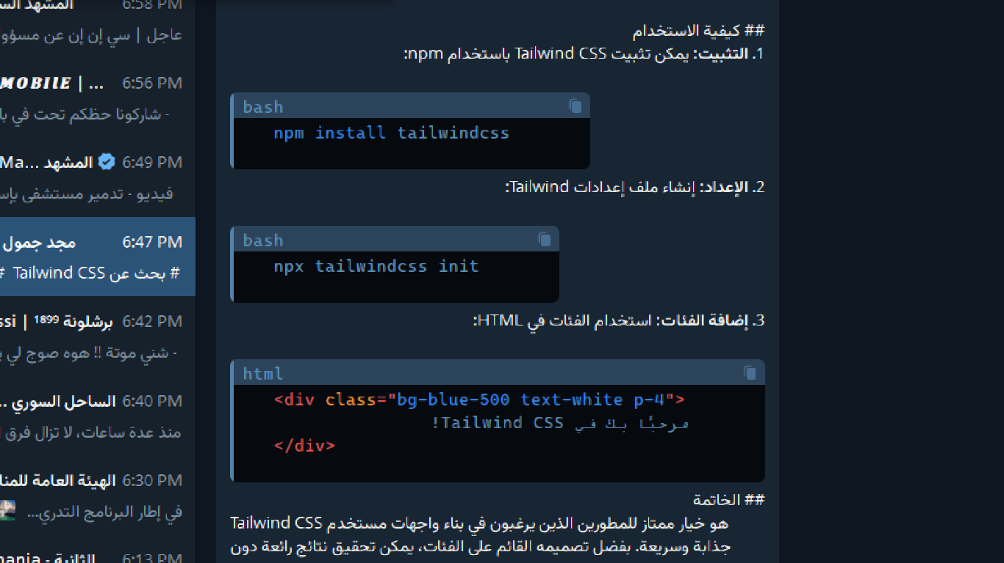

- Setup: Create a Tailwind Settings file:

- Add Categories: Use Categories in HTML:

5.2 Test Cases:
Test Case ID | Req. ID | Test Type | Test Case Name | Description | Input | Expected Output | Actual Result / Status | Result
TC.001 | Uc-01 | Black Box | Manage user data (add/modify/delete) | Verify that an admin can add, modify, or delete a user account successfully. | Admin selects a user, chooses Add/Modify/Delete, and confirms the action. | User list updates to reflect the change; a success message is displayed. | Successful: user record was added/modified/deleted as expected. | Passed
TC.002 | Uc-02 | Black Box | Modify system settings | Verify that an admin can update system settings such as work units/departments. | Admin edits a department name and clicks Save. | Settings are updated and a confirmation notification appears. | Successful: the updated setting was saved and reflected system-wide. | Passed
TC.003 | Uc-03 | Black Box | Monitor activity logs | Verify that the admin can view and filter system activity logs. | Admin opens Activity Logs and applies a date filter. | Logs are displayed in chronological order, filtered by the selected date. | Successful: filtered log list displayed correctly with no data modified. | Passed
TC.004 | M-01 | Black Box | Create production and profit report | Verify that a manager can generate a production/profit report for a given period. | Manager selects report type and date range, then clicks "Create Report". | Report is generated with total production, costs, and profit/loss. | Successful: report generated and displayed with correct calculated indicators. | Passed
TC.005 | M-02 | Black Box | Generate production and profit report from available data | Verify report generation logic aggregates production, cost, and sales data correctly. | Manager triggers report generation with existing production and cost records. | System collects and analyzes data, then displays the report on screen. | Successful: data aggregation and report rendering completed as expected. | Passed
TC.006 | M-03 | Black Box | Plan and schedule resources (food/fuel) | Verify the manager can create a resource schedule based on poultry count and stage. | Manager enters poultry count, growth stage, and selects a scheduling start date. | System calculates required food/fuel quantities and saves the schedule. | Successful: schedule created and stored with correct calculated quantities. | Passed
TC.007 | M-04 | Black Box | Send new purchase order to supplier | Verify the manager can create and send a purchase order to a registered supplier. | Manager selects supplier, item, quantity, then clicks "Send Order". | Order is created with status "Pending" and supplier is notified. | Successful: order created and delivered to the correct supplier queue. | Passed
TC.008 | M-05 | Black Box | Track and analyze performance data | Verify the manager can view performance trends to identify improvement areas. | Manager opens the performance analytics dashboard for a selected period. | System displays trend charts and highlights underperforming metrics. | Successful: analytics dashboard rendered correct trend data. | Passed
TC.009 | M-06 | Black Box | Request feed from the food supplier | Verify the manager can submit a feed request to a food supplier. | Manager selects feed type, quantity, and clicks "Submit Request". | Request is sent to the supplier and appears in their pending orders. | Successful: feed request delivered and visible to the food supplier. | Passed
TC.010 | M-07 | Black Box | Request vaccines and medicines from the veterinarian | Verify the manager can request medical supplies through the system. | Manager selects vaccine/medicine type and quantity, then submits the request. | Request appears in the veterinarian's incoming requests list. | Successful: request was created and routed to the veterinarian correctly. | Passed
TC.011 | M-08 | Black Box | Request equipment from the equipment supplier | Verify the manager can request equipment items via the system. | Manager selects equipment item, quantity, and submits the request. | Request is recorded and forwarded to the relevant supplier. | Successful: equipment request logged and forwarded correctly. | Passed
TC.012 | M-09 | Black Box | Assign a new worker | Verify the manager can assign a new employee to the facility. | Manager enters employee details and assigns a role, then saves. | New employee record is created and appears in the staff list. | Successful: employee record created with correct role assignment. | Passed
TC.013 | M-10 | Black Box | Send recommendation to improve activity logs | Verify the manager can submit a recommendation regarding activity log quality. | Manager writes a recommendation note and clicks "Submit". | Recommendation is saved and visible to the system admin. | Successful: recommendation stored and made visible as expected. | Passed
TC.014 | M-11 | Black Box | Set minimum inventory alert threshold | Verify the manager can configure a low-stock alert threshold for feed/fuel. | Manager sets minimum quantity value and saves the setting. | System stores the threshold and triggers alerts when stock falls below it. | Successful: threshold saved; alert triggered correctly on low-stock simulation. | Passed
TC.015 | M-12 | Black Box | Analyze performance data for strategic decisions | Verify the system produces a comprehensive performance analysis report. | Manager requests a full performance analysis for a selected period. | System returns a report highlighting improvement opportunities and KPIs. | Successful: analysis report generated with accurate improvement indicators. | Passed
TC.016 | Vet-01 | Black Box | Record veterinary examination (individual/group) | Verify the veterinarian can log an examination for an individual bird or flock. | Vet selects case type, enters symptoms/findings, and saves the record. | Examination is saved and linked to the correct bird/flock health record. | Successful: examination record saved and linked correctly. | Passed
TC.017 | Vet-02 | Black Box | Monitor prevention and treatment plans | Verify the veterinarian can update a flock's treatment/prevention plan. | Vet selects a flock, updates the treatment plan, and saves changes. | Plan is updated and relevant supervisors are notified. | Successful: plan updated and notification sent to supervisor. | Passed
TC.018 | Vet-03 | Black Box | Provide health environment recommendations | Verify the veterinarian can submit environmental improvement recommendations. | Vet reviews environmental data and submits a recommendation note. | Recommendation is saved and linked to the relevant barn/date. | Successful: recommendation stored and linked to the correct barn record. | Passed
TC.019 | Vet-04 | Black Box | Provide specialized dietary plan | Verify the system generates a dietary plan based on flock criteria. | Vet specifies flock type, age stage, and goal, then generates the plan. | System returns a dietary plan matching the specified criteria. | Successful: dietary plan generated matching input criteria. | Passed
TC.020 | Vet-05 | Black Box | Display and print reports records | Verify the veterinarian can view and print an existing report. | Vet selects a report from the list and clicks "Print". | Report is displayed and sent to the printer successfully. | Successful: report displayed and print job completed. | Passed
TC.021 | Emp-01 | Black Box | Record daily feeding data | Verify the employee can log daily feeding quantities for a flock. | Employee enters feed quantity used and submission date, then saves. | Feeding record is saved and stock quantity is updated accordingly. | Successful: feeding record saved and stock updated correctly. | Passed
TC.022 | Emp-02 | Black Box | Report abnormalities using simple forms | Verify the employee can submit an abnormality report through a simple form. | Employee selects abnormality type, adds a note, and submits. | Report is created and routed to the manager/veterinarian. | Successful: abnormality report submitted and routed correctly. | Passed
TC.023 | Emp-03 | Black Box | Update facility cleanliness status | Verify the employee can update the cleanliness status of a barn/area. | Employee selects an area and updates its cleanliness status. | Status is updated and reflected on the manager's dashboard. | Successful: cleanliness status updated and visible on the dashboard. | Passed
TC.024 | Emp-04 | Black Box | Assist with sorting and packing operations | Verify the employee can log a sorting/packing operation entry. | Employee enters batch details and confirms the packing operation. | Operation record is saved and linked to the correct batch. | Successful: sorting/packing entry saved with correct batch link. | Passed
TC.025 | Emp-05 | Black Box | View and print sorting and packing operations | Verify the employee can view and print sorting/packing records. | Employee opens the operations list and clicks "Print" on a record. | Record is displayed and sent to the printer. | Successful: record displayed and printed without errors. | Passed
TC.026 | Emp-06 | Black Box | View and print supplier/veterinarian reports | Verify the employee can view and print reports submitted by suppliers or the veterinarian. | Employee selects a report from the shared reports list and clicks "Print". | Report content is displayed accurately and printed successfully. | Successful: report displayed and printed with correct content. | Passed
TC.027 | Emp-07 | Black Box | Edit reports received from suppliers/veterinarian | Verify the employee can edit a report received from a supplier or veterinarian. | Employee opens a report, edits a field, and clicks "Save". | Report is updated and the change is logged. | Successful: report updated and change logged correctly. | Passed
TC.028 | Emp-08 | Black Box | Record daily attendance and departure times | Verify the employee can check in/out and the times are logged. | Employee clicks "Check In" at arrival and "Check Out" at departure. | Attendance record is saved with accurate timestamps. | Successful: attendance times recorded accurately. | Passed
TC.029 | RB-01 | Black Box | Add details of supplied food items | Verify the food supplier can add a new supply record with quantity/quality. | Supplier enters food type, quantity, and quality grade, then saves. | Supply record is created and visible to the facility manager. | Successful: supply record created and visible as expected. | Passed
TC.030 | RB-02 | Black Box | Submit direct quotation | Verify the food supplier can submit a price quotation via the system. | Supplier enters item, price, and quantity, then clicks "Submit Quotation". | Quotation is saved and sent to the manager for review. | Successful: quotation submitted and delivered to the manager. | Passed
TC.031 | RB-03 | Black Box | Update order status (Delivered/Not Delivered) | Verify the food supplier can update the delivery status of an order. | Supplier selects an order and changes its status to "Delivered". | Order status updates immediately and the manager is notified. | Successful: status changed to "Delivered" and notification sent. | Passed
TC.032 | RB-04 | Black Box | Edit and delete quotations | Verify the food supplier can edit or delete a previously submitted quotation. | Supplier selects a quotation and chooses Edit or Delete. | Quotation is updated or removed accordingly. | Successful: quotation edited/deleted as requested. | Passed
TC.033 | RB-05 | Black Box | Provide food consumption reports | Verify the food supplier can submit a consumption report for future planning. | Supplier enters consumption figures for a period and submits. | Report is saved and visible to the manager for planning purposes. | Successful: report saved and available to the manager. | Passed
TC.034 | RB-06 | Black Box | Update supplier profile and contact information | Verify the food supplier can update their profile details. | Supplier edits phone/contact fields and clicks "Save". | Profile is updated and the change is reflected system-wide. | Successful: profile information updated correctly. | Passed
TC.035 | RB-07 | Black Box | Edit, delete, and print food consumption reports | Verify the food supplier can manage existing consumption reports. | Supplier selects a report and chooses Edit, Delete, or Print. | Selected action is executed and confirmed with a system message. | Successful: report action (edit/delete/print) executed correctly. | Passed
TC.036 | FS-01 | Black Box | Report a delivery problem | Verify the fuel supplier can report an issue with a delivery operation. | Supplier selects a delivery, specifies problem type, and submits the report. | Report is saved and visible to facility management for action. | Successful: report submitted and visible to management. | Passed
TC.037 | FS-02 | Black Box | Record fuel quantity supplied | Verify the fuel supplier can log the quantity of fuel delivered in an operation. | Supplier enters fuel type, quantity, and supply date, then saves. | Supply record is saved and available for management monitoring. | Successful: supply record saved and available as expected. | Passed
TC.038 | FS-03 | Black Box | Submit periodic fuel consumption report | Verify the fuel supplier can submit a periodic consumption report. | Supplier selects reporting period, enters consumption data, and submits. | Report is saved and available for management analysis. | Successful: report submitted and saved correctly. | Passed
TC.039 | FS-04 | Black Box | Provide reports about fuel consumption | Verify the fuel supplier can generate a consumption report from existing data. | Supplier clicks "Provide Fuel Report" and enters report details. | System saves the report and confirms successful submission. | Successful: report provided and saved as confirmed by the system. | Passed
TC.040 | FS-05 | Black Box | Provide fuel efficiency recommendations | Verify the fuel supplier can submit recommendations to reduce fuel costs. | Supplier writes a recommendation and clicks "Submit Recommendation". | Recommendation is saved and visible to management for review. | Successful: recommendation submitted and stored correctly. | Passed
TC.041 | FS-06 | Black Box | Edit, delete, and print fuel consumption report | Verify the fuel supplier can manage existing fuel consumption reports. | Supplier selects a report and chooses Edit, Delete, or Print. | Selected action is executed and confirmed with a system message. | Successful: report action (edit/delete/print) executed correctly. | Passed

5.3 System interfaces:

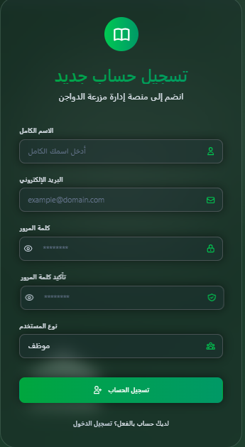
1- Sign up:

2- Log in:
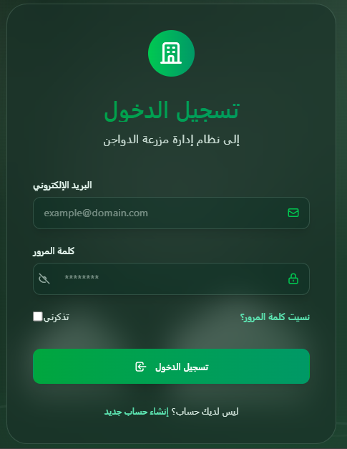

3- Users management :
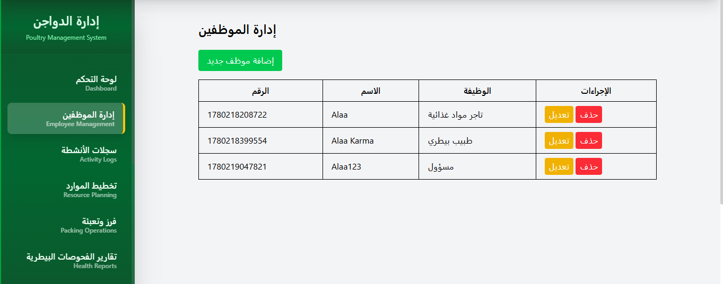

4- Sorting and packing page:
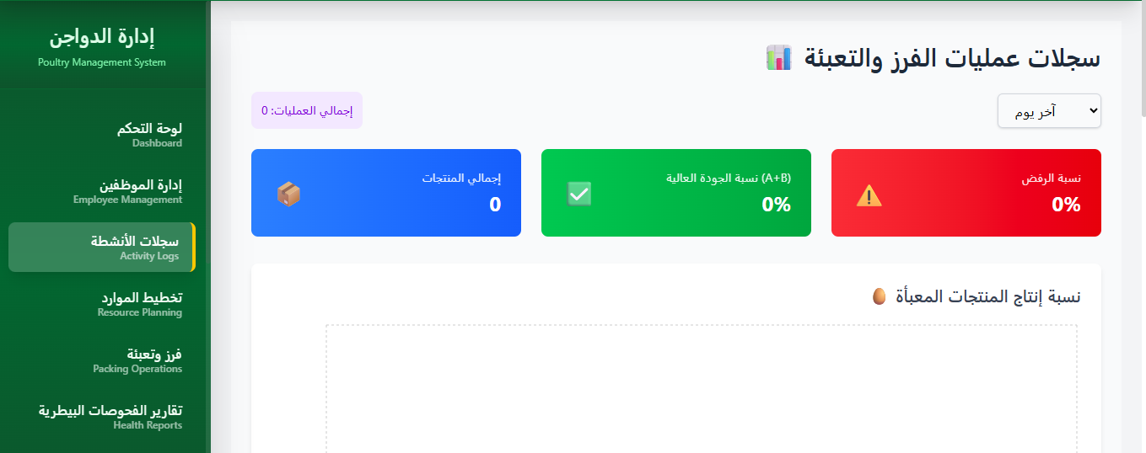

5- Resource planning page:
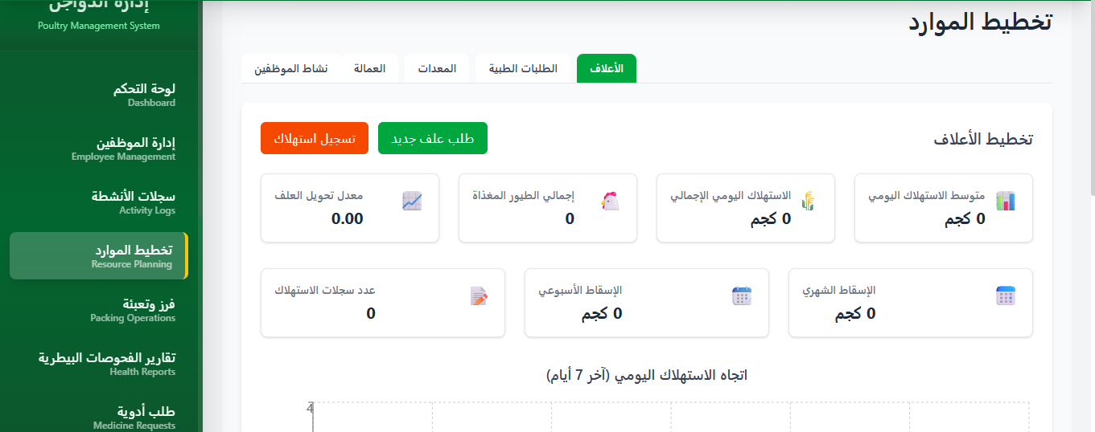

6-Cleaning reports page:
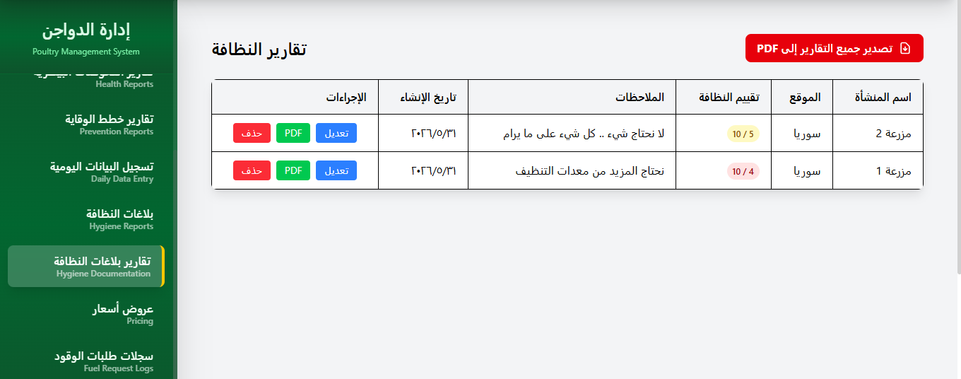

5.4 Sitemap:
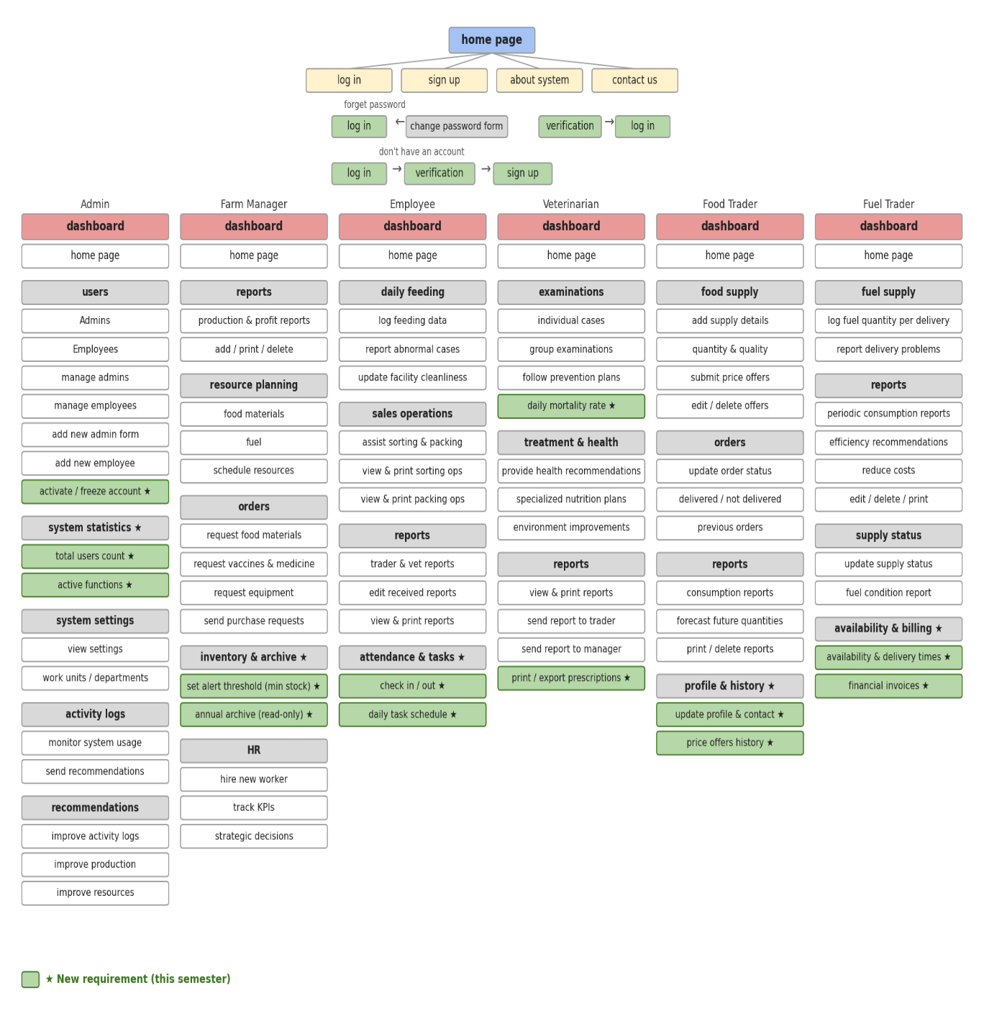

Chapter six: Conclusions and Future Prospects

6.1 Conclusion:
In conclusion, this project involved the design and development of a comprehensive poultry farm management system aimed at improving operational efficiency, monitoring flock health, and streamlining daily farm tasks. The system enables farmers to record and track key metrics such as bird counts, feed consumption, medication schedules, egg production, and mortality rates through an intuitive and easy-to-use interface. The project focused on balancing simplicity in user interaction with robust backend performance, ensuring that essential features—such as inventory management, vaccination alerts, and report generation—are both accessible and reliable. Furthermore, this work contributed to deepening the understanding of full-stack web development and how to build an integrated system that connects farm data with actionable insights, while also enhancing skills in software analysis and design. Future enhancements could include real-time environmental monitoring via IoT sensors, predictive analytics for disease outbreaks, and mobile notifications for critical alerts, bringing the system closer to the standards of modern smart farming solutions.

6.2 Future work:
work on integrating Artificial Intelligence into the system to enable:
Predictive analytics for future feed and fuel consumption.

6.3 Final Goal:
To modernize agricultural facility management with a secure, user-friendly, and intelligent system that boosts productivity, minimizes waste, and supports data-driven decision-making.

6.4 References:
- MongoDB: MongoDB Documentation. Available at: https://www.mongodb.com/docs/
- Express.js: Express.js Guide. Available at: https://expressjs.com/
- React: React Documentation. Available at: https://react.dev/
- Node.js: Node.js Documentation. Available at: https://nodejs.org/
- Tailwind CSS: Tailwind CSS Documentation. Available at: https://tailwindcss.com/
- Stack Overflow: Stack Overflow Developer Community. Available at: https://stackoverflow.com/
- W3Schools: W3Schools Online Web Tutorials. Available at: https://www.w3schools.com/

